**General Information for QEDM/Cybersecurity consideration:**

Draft minutes 9.04.24 (joint IR/tech), 9.22.24 (joint RMQ IR/TEIS), 7.06.23 (joint BPS)

**Key size:**

**2048-bit asymmetric key** is still considered **viable and secure** for most applications in 2025, but with some caveats depending on the context:

**✅ When 2048-bit RSA is still viable:**

* **General web encryption (HTTPS)**: Most browsers and servers still accept 2048-bit RSA keys.
* **Email encryption and digital signatures**: Still widely used and supported.
* **Short- to medium-term security**: If the data doesn't need to remain secure for more than 10–15 years, 2048-bit is generally sufficient.

**Browser penetration:**

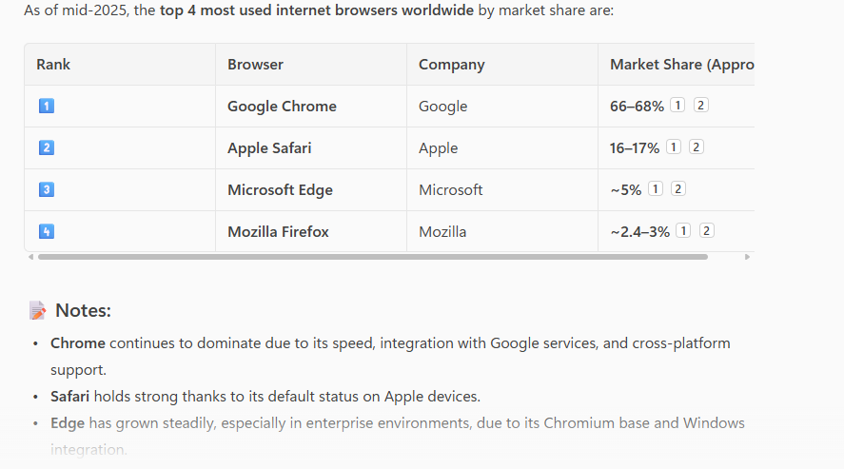

**EDM Port analysis:**

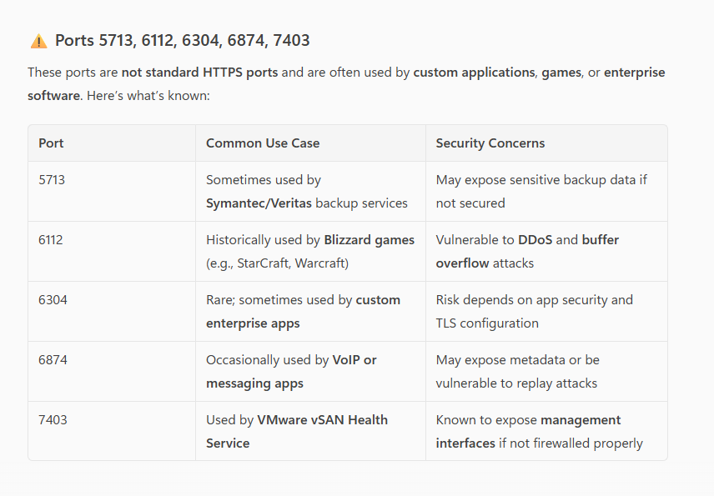

**PGP Viability:**

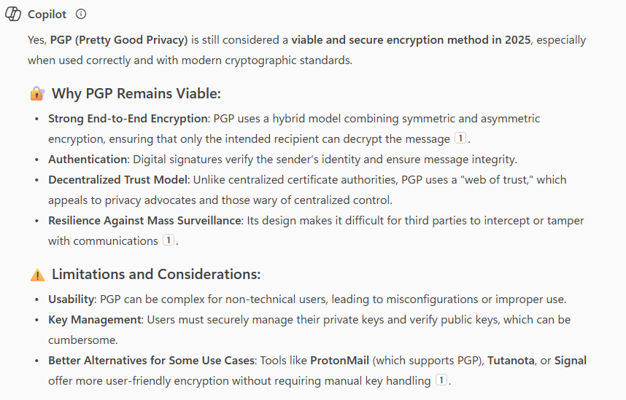

**Basic Authentication:**

