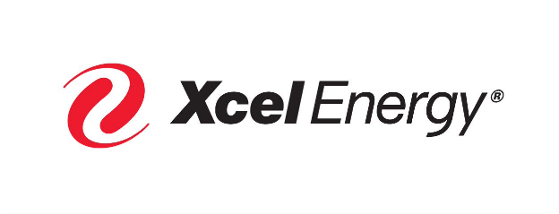
Cassy Koester Manager
Gas Supply
Xcel Energy Services Inc.

1800 Larimer Street, Suite 1000 Denver, CO 80202
(303)571-2826
Cassy.koester@xcelenergy.com

September 25, 2023

Rae McQuade, President
North American Energy Standards Board
1415 Louisiana, Suite 3460
Houston, TX 77002
naesb@naesb.org

Re: Request for Initiation of a NAESB Standard for Electronic Business Transactions or
Request for Enhancement of a NAESB Standard for Electronic Business Transactions – R23001

Enhancement to the NAESB Base Contract for Sale and Purchase of Natural Gas Force Majeure Terms

Dear Ms. McQuade:

Xcel Energy Services Inc. (XES), on behalf of its affiliate operating companies Northern States Power Company, a Minnesota corporation; Northern States Power Company, a Wisconsin corporation; Southwestern Public Service Company; and Public Service Company of Colorado submits these formal comments in response to the No Action Recommendation vote that passed during the WGQ Contracts Subcommittee meeting on September 14, 2023. We urge NAESB’s WGQ Executive Committee to move this process forward in a good faith effort to develop consensus-based improvements to the force majeure provisions of the Contract.

A strength of the NAESB process is the historical willingness of representatives of various sectors to come together in good faith to work through important issues. As discussed below, recent experience suggests a need to revisit expectations of gas suppliers and gas purchasers regarding cold weather events to ensure the availability of natural gas to service electric and natural gas customers. Termination of this process before it even begins will perpetuate a status quo that is failing to meet the needs of the country.

The stakeholder process undertaken by the Southwest Power Pool, Inc. (SPP) that led to the initiation of this proceeding was precipitated at least in part by the gas supply interruptions experienced in the southwest during Winter Storm Uri (Uri) in February, 2021. A report issued by the Federal Energy Regulatory Commission (FERC) and the North American Electric Reliability Corporation (NERC) relating to electric supply interruptions experienced during Uri identified the primary cause of that event to be failure of generating units unprepared for cold weather.

A secondary cause of the event was significant gas production declines leading to loss of fuel to gas generators. Between February 8 and February 17, 2021, natural gas production in the lower 48 states fell by 28%. In at least portions of Texas, Louisiana, and Oklahoma, gas production fell 50% when compared to January 2021. The Report indicates that 31% of generating unit failures were attributable to lack of natural gas.

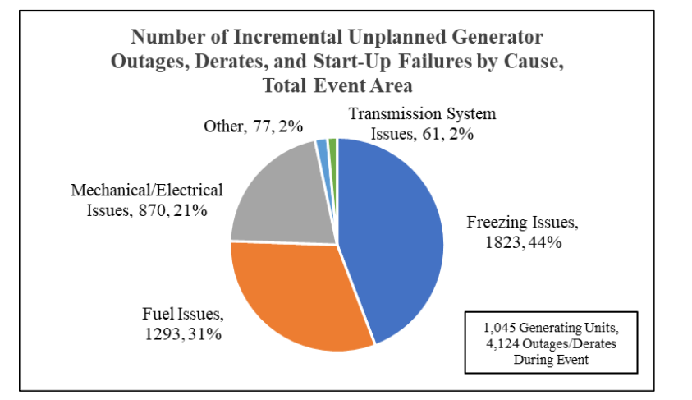

The Report also indicates that at least 210 people died during Uri, with most of those deaths attributable to power outages.

Uri was followed by another extreme weather event in the northeastern part of the country in December, 2022: Winter Storm Elliott (Elliott). PJM indicates that 24% of its generating capacity was offline, with 70% of those unplanned outages involving gas-fired generators. PJM has concluded that most of the generating unit outages were attributable to generating equipment failures due to extreme cold though broader issues of gas availability also contributed to outages. Specifically, natural gas output in the Appalachian Basin dropped by 27% during Elliott, the steepest decline since 2013. Elliott affected almost 250 million residents in the United States and Canada, and dozens of people are believed to have died due to the storm. FERC and NERC have initiated an investigation into the causes of unit outages during Elliott and we expect the report on this investigation to provide a clearer picture of the impact of natural gas production shortages on generator availability during the storm.

In response to Winter Storm Uri, NERC (with industry support and FERC approval) adopted new mandatory weatherization requirements for generating units that will take effect on October 1, 2024. These measures are intended to minimize weather-related outages of generators to ensure continued electric service during future severe weather events. Generally, these rules require cold weather preparedness plans, emergency operations plans and implementation of freeze protection measures to ensure continuous operations during extreme cold weather.

These efforts to improve weatherization of natural gas generating facilities will address the primary causes of generator outages during Uri and Elliot. They will not, however, address the significant secondary causes of generator outages—unavailability of previously committed natural gas. In the face of expected future, extreme and protracted cold weather events, the time is ripe to address cold-weather protection of gas supplies. Along with the electric industry taking steps to better protect generating equipment from cold weather events, a dialogue about how cold weather-related interruptions of gas production can be alleviated is critically important.

We urge the WGQ Executive Committee to carefully consider the importance of this effort and make the decision to move this process forward in an effort to explore reasonable solutions that will benefit both the electric and gas industries as well as consumers of the products we produce.

Respectfully,

/s/
Cassy Koester
Manager Gas Supply
Xcel Energy Services Inc.
1800 Larimer Street, Suite 10
Denver, CO 80202
Cassy.koester@xcelenergy.com
303-571-2826

The February 2021 Cold Weather Outages in Texas and the South Central United States, FERC-NERC-Regional Entity Staff Report, November, 2021, The February 2021 Cold Weather Outages in Texas and the South Central United States | FERC, NERC and Regional Entity Staff Report | Federal Energy Regulatory Commission (Report) at page 11.
Report at page 13.
Report at page 16.
Report at page 9.
Winter Storm Elliott, Event Analysis Report, July 17, 2023, PJM, 20230717-winter-storm-elliott-event-analysis-and-recommendation-report.ashx (pjm.com)
U.S. Natural Gas Production Plunges as Winter Storm Wreaks Havoc, December 28, 2022, U.S. Natural Gas Production Plunges As Winter Storm Wreaks Havoc | OilPrice.com.

