OASIS Subcommittee Meeting
November 28-30, 2017
Hosted by Southern Company Services, Inc.
Alabama Power Corporate Headquarters Building
600 North 18th Street
Birmingham, Alabama

Tuesday, November 28
9:00am – 4:00pm WEQ OASIS Subcommittee Room 4B
Wednesday, November 29
9:00am – 4:00pm WEQ OASIS Subcommittee Room 4B
Thursday, November 30
9:00am – 12:00pm WEQ OASIS Subcommittee Room 4F

Directions from Birmingham International Airport
As you leave the airport area, you will be on Airport Boulevard. Follow the signs leading to I-59 South (toward Tuscaloosa) and I-20 West. Take the 22nd St. exit (on your left). Turn left onto 22nd St. Travel south to 6th Ave. North (about 3 blocks). Turn right on 6th Ave. to 18th St. North. Enter building on 18th St. North side between 6th and 7th Ave. North. Stop at desk in atrium to check in.
Parking
For visiting employees or guests, there are three lots that surround the APC headquarters building. Our visitor's lot (Lot #1) is directly across from the Atrium entrance on 18th Street. Lot #2 is on the corner of 8th Avenue and 18th Street. There is also a lot on the corner of 6th Avenue and 17th Street (Lot #5).
Two (2) pay-for-parking lots can be found on 18th Street. One is a Central Parking lot ($3.00 per day), which is on the corner of 6th Avenue and 18th Street. There is also a Birmingham City Parking Deck, one half-block south from the Central lot on 18th Street ($8.00 per day/$1.00 per hour).

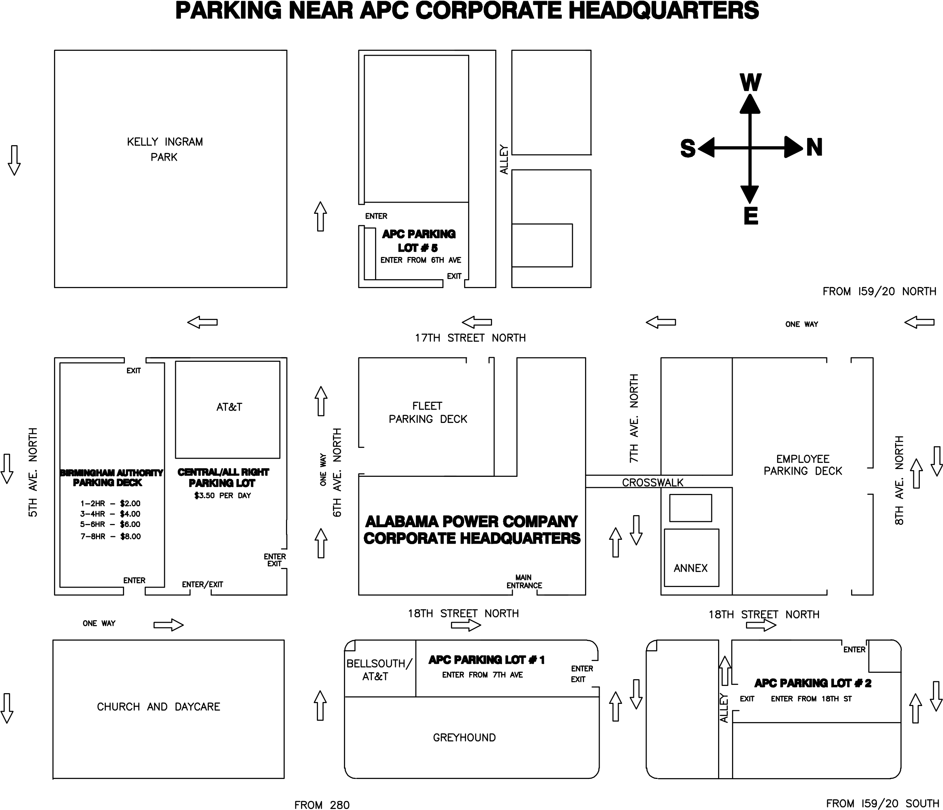
Hotels (with Southern Company Corporate Rates)

Hampton Inn & Suites Birmingham Downtown – The Tutwiler (.4 miles)
2021 Park Place
Birmingham, Alabama 35203

Sheraton Birmingham Hotel (.6 miles)
2101 Richard Arrington Jr. Boulevard North
Birmingham, Alabama 35203

Residence Inn Birmingham Downtown at UAB (1.1 miles)
821 20th Street South
Birmingham, Alabama 35205

