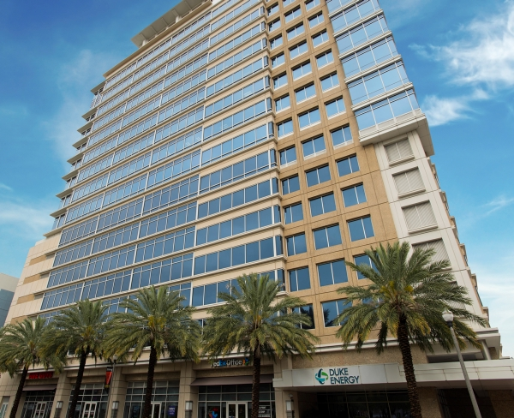

Meeting Location
Duke Energy
299 1st Avenue North
St. Petersburg, FL 33701
Room- FLRH 801

Parking – Sundial Parking Lot
117 2nd St. N., St. Petersburg, FL 33701

Directions
From Tampa Airport to Sundial Parking
- Go N. on George J. Bean Pkwy toward Ground Transportation
- Merge onto I-275 toward St. Petersburg
- Merge onto I-375 E. via EXIT 23A on the left toward Sundial/The Pier
- I-375 E becomes 4th Ave. N./US-92 E/FL-595
- Turn right onto 4th St N./FL-687
- Take the 2nd left onto 2nd Ave. N.
- Turn right onto 2nd St N.
- 117 2nd St. N., St. Petersburg, FL 33701 (117 2nd St. N. is on the left)

Ground Transportation
Rental Cars
Shuttle Service

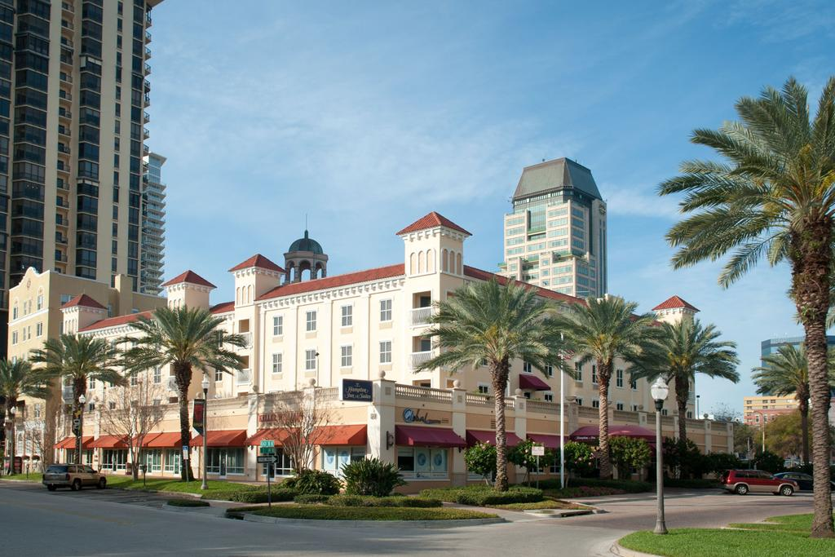

Hampton Inn & Suites
80 Beach Drive Northeast
St Petersburg, FL 33701
727-892-9900

Valet Parking only - $16.00 per day

During your stay your hotel provides
- Complimentary Internet
- Gym/fitness c enter use
- Outdoor pool
- Automated Teller (ATM)
- Baggage Storage
- Beverage Area, Complimentary
- Breakfast Area, Complimentary
- Coin Laundry ($1.50)
- Electric Service
- Elevators
- Laundry/Valet Service
- Luggage Hold
- On-Site Convenience Store
- Safety Deposit Box
- Snack Shop

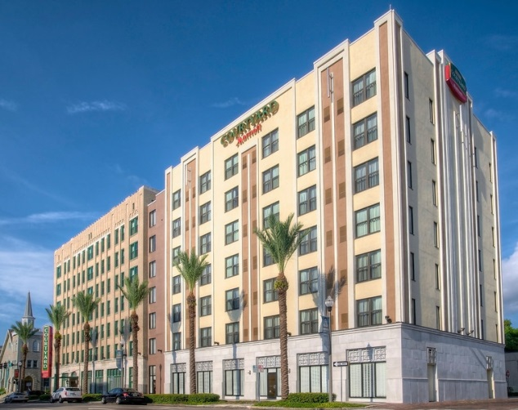

Marriott Courtyard
300 4th Street North
St Petersburg, FL 33701
727-450-6200

Valet Parking only - $15.00 per day

During your stay your hotel provides
- Shuttle service to Duke Energy and downtown area
- Complimentary Internet
- Complimentary breakfast
- BISTRO
- Beauty shop, nearby (referral at front desk)
- Automated Teller nearby
- Coffee/tea in-room
- Housekeeping service daily
- Laundry on-site
- Laundry on-site, coin operated
- Newspaper in lobby
- Phone calls: Toll-free
- Safe deposit boxes, front desk
- Valet dry-cleaning
- Mobility accessible rooms
- Fitness Center

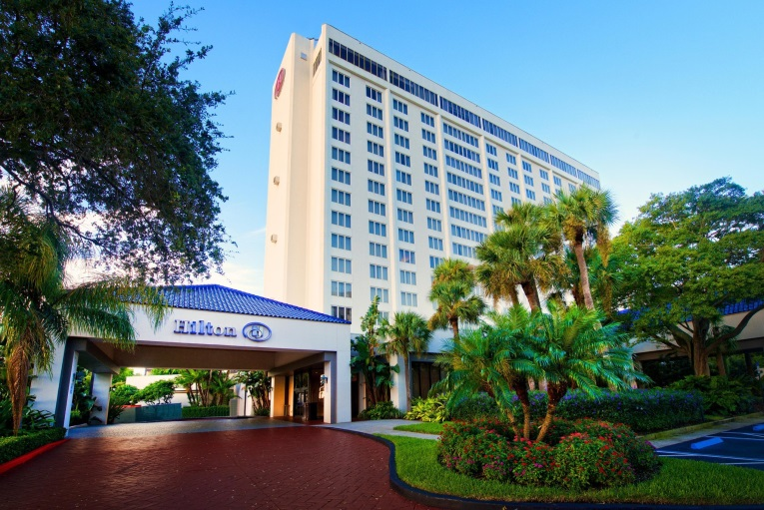

Hilton St. Petersburg Bayfront
333 1st Street South
St. Petersburg, FL 33701
727-894-5000

Self -parking only - $16.00 per day

During your stay your hotel provides
- Fitness Room
- Jogging path along Bay
- Pool
- Refrigerators in rooms
- 24 hr Pavilion Pantry Market
- Automated Teller (ATM)
- Baggage Storage
- Bar Area
- Concierge Desk
- Digital Key Available
- Electric Service
- Elevators
- Gift Shop
- Guest Activity/Recreation Desk
- Laundry/Valet Service
- Lounge
- Luggage Hold
- Multi-Lingual Staff
- Room Service

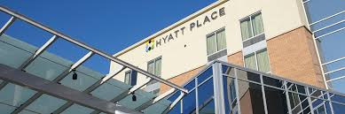
Hyatt Place St. Petersburg / Downtown
25 2nd Street North
St. Petersburg, FL 33701
727-220-0950

Self -parking only - $12.00 per day

During your stay your hotel provides
- Free Wi-Fi
- Free breakfast of cage-free eggs, all-natural bacon, Greek yogurt, and more
- All-day dining from the 24/7 Gallery Market and 24/7 Gallery Menu
- Coffee to Cocktails Bar
- Heated rooftop pool
- 24/7 Gym
- Laundry and dry cleaning
- Pet-friendly rooms

