Request:

Consider modifications to existing tagging functional specifications to incorporate battery, pumped storage or other future bi-directional (generation and load) type resources. Changes to the WEQ Electronic Tagging Specifications have been infrequent and minor over the last several years. However, storage type resources have come online at a rapid pace and there is a growing desire to have a Transaction Product Type that can support a single resource that has ability to go in both directions. The request is to develop a Transaction Product Type that can support batteries and future similar technology.

Issue:

Currently Electronic Tag specification limits energy profiles to positive values and the direction of the tag (Import, Export or Gen/Load is determined by the physical path on the E-Tag. Tagging a bi-directional resource currently requires 2 separate E-tags (1 for gen and 1 for load) and in most cases may require 2 separate Transmission Service Reservations (TSR) for the transmission. Having 2 E-tags per resource with a growing battery portfolio increases operations workload and may require additional data storage. It can also be prone to error by either updating the energy profile on the incorrect side of tag or using the incorrect OASIS number for the transmission reservation.

Solution:

Develop a new Transaction Product Type that can support a battery resource.

* Model the Transaction Product type around Pseudo-Tie type tag since it is likely that a battery that a BA attains outside of the native balancing area would likely be a pseudo type. Modeling as a pseudo tie would also help keep NSI out of the equation which could lead to additional work.
* When selecting new Transaction Product Type the tag author will need to make only one tag that can be used for both directions.
* The direction of the tag would be determined by positive or negative values.
  + Negative value will be the opposite direction of physical path on the E-Tag.

Below illustrates what that may look like:

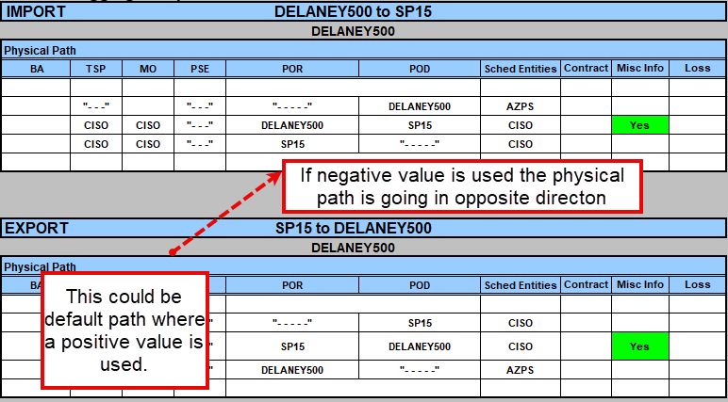

Since this is modeled around a Pseudo Type Transaction Type, the NSI will always be zero, so there is no significance in direction. However, there may be significance in monitoring transmission usage.

Cons:

Currently there are no known transmission service providers in the Western Interconnection that sell a bi-directional transmission product and this could be a change to their Tariff and OASIS or transmission offering types. This also could have impacts that trigger changes in other tools and applications.

Possible Impacted Systems:

* E-Tagging Systems
* OASIS
* Scheduling systems
* EMS

Withdraw Request:

CAISO appreciates the opportunity to discuss this issue with CISS. However, after some consideration and reassessment of the issue, CAISO is requesting to withdraw the request for modification of the existing E-tagging functionality to include a bi-directional scheduling option.

CAISO has successfully implemented a process that helps mitigate many of the issues with bi-directional experienced earlier on.

Below highlights some of the requirements and describes the process at a high level:

Customer requirements for Bi-Directional resources physically outside of the CAISO

* Must be Pseudo-Tie type resource (if grid charging)
* Must secure Firm Transmission service in both directions
  + Charging (From CAISO to Resource Load)
  + Discharging (From Battery to CAISO Load)
* When tagging, the charging and the discharging transactions must be tagged separately

CAISO has implemented a new display in internal scheduling system that aids operators in identifying the tag direction, transmission profile and energy profile. The display keys in on physical segments of the tag to determine charging or discharging direction. CAISO identifies the tags transaction Type = Pseudo and “Resource Type” = TNGR (Tie-Non Generator Resource) and drop these resources into new display

Note: “Resource Type” is internal mapping

The physical segments that CAISO keys in on for bi-directional resources:

* POR/POD
* ZPTG (Zero Participating Tie Generator) used as a Resource ID for pseudo ties as the “Export” for Discharge side and “Import for charging side.
* Source/Sink

In the tagging examples below, the resource ID BATTERY_2_SB1 is used on both E-Tags but for different purposes (charge/discharge).

To identify the discharge side, the ZPTG will = Export. In this case, ZPTG_BATTERY230_E_WHL_BATTERY1 and Source = BATTERY1

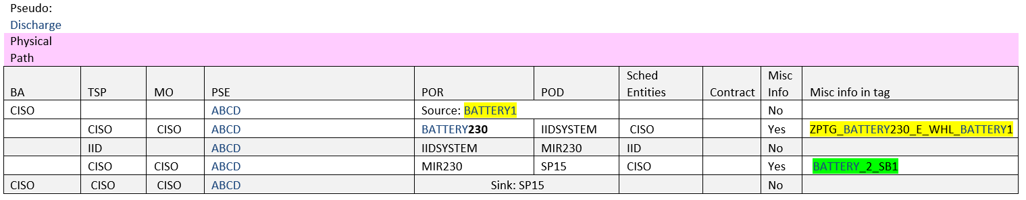

To identify the Charge side, the ZPTG will = Import. In this case, ZPTG_BATTERY230_I_WHL_BATTERY1 and Sink = BATTERY1

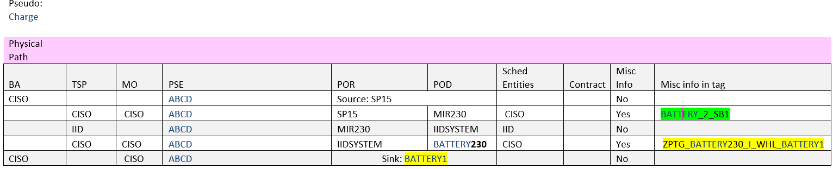

Another validation is to look at the line where the Resource ID “BATTERY_2_SB1” is and evaluate the POR/POD to determine the direction.

If BATTERY_2_SB1 is on POR=MIR230 POD= SP15, then Tag is Discharge.

If BATTERY_2_SB1 is on POR= SP15, POD= MIR230, then Tag is Charge.

Once the direction is identified the resource will be counted in new display

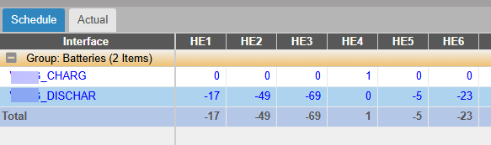

Clicking into the linked number will bring you to the correct E-Tag.