Purpose
This document justifies proposed changes to the North American Energy Standards Board (NAESB) standard WEQ-006 v3.1. These changes were done at the request of NAESB. The information in this document was shared with the WECC Performance Work Group (PWG) for coordination of industry expertise; however, this document may not contain all the information on this topic due to the time constraint in responding to NAESB’s request.

Proposed Changes
It is proposed that the following changes take place.
- Section 006-3: The Interconnection Time Monitor must calibrate its Time Error device at least annually to the National Institute of Standards and Technology (NIST) Time if the time error device inherently requires calibration.
- Section 006-5: Remove the two columns that reference the West. This includes the initiation and termination values.
- Section 006-9: Remove this paragraph.
- Section 006-10: There has been some discussion whether this section is tied into the previous paragraph for the Western Interconnection, or if it is a stand-alone section that references all interconnections. If it is only for the Western Interconnection, it is recommended to remove it or redefine it under its own section (ex., 006-10 Premature Termination of a Time Error Correction). If it is a stand-alone section, the suggestion to redefine it also applies.

Justification for Proposed Changes
The following information is provided as context to justify the proposed removal of the Western Interconnection from WEQ-006.

Current MTEC Process in the Western Interconnection
When the NERC Reliability Standard BAL-004-0 became inactive on April 1, 2017, the Western Interconnection stopped performing Manual Time Error Corrections (MTEC) for predefined thresholds and adopted the guidance from the NERC Time Monitoring Reference Document that established a time monitor for each interconnection and stated that an MTEC could be initiated for reliability purposes. Now, RC West serves as the Interconnection Time Monitor in the West. Per RC West’s operating procedures, MTECs are not initiated in the Western Interconnection for predefined thresholds but may be initiated for reliability concerns or other unforeseen reasons.
References:
- NERC Time Monitoring Reference Document: https://www.nerc.com/comm/OC/ReferenceDocumentsDL/Time_Monitoring_Reference_Document_v5.pdf
- RC West Time Error Correction Procedure: http://www.caiso.com/Documents/RC0220.pdf

Automatic Time Error Correction
Since February 2003, Balancing Authorities (BA) in the Western Interconnection have participated in a process called Automatic Time Error Correction (ATEC). This process is more efficient and reliable than MTECs in controlling time errors caused by inadvertent accumulations. When standards were implemented in response to the Energy Policy Act of 2005, the Western Interconnection adopted a regional standard requiring the participation in ATEC by all BAs in the Western Interconnection. The regional NERC Reliability Standard BAL-004-WECC-2 requires that BAs in the Western Interconnection participate in the ATEC process continuously. This standard provides a common way for BAs to calculate and track their accumulated Primary Inadvertent Interchange (PII) and to pay it back in a coordinated way that enhances the reliability of the interconnection. This method is more effective at managing time errors than MTEC for the Western Interconnection.
To help monitor the performance and effectiveness of ATEC over time, the WECC PWG tracks the accumulation of each BA’s PII, as well as the time error. Below is a graph of these two operating data sources trended over time since 2009, as well as information and conclusions about the management of inadvertent time errors in the Western Interconnection.
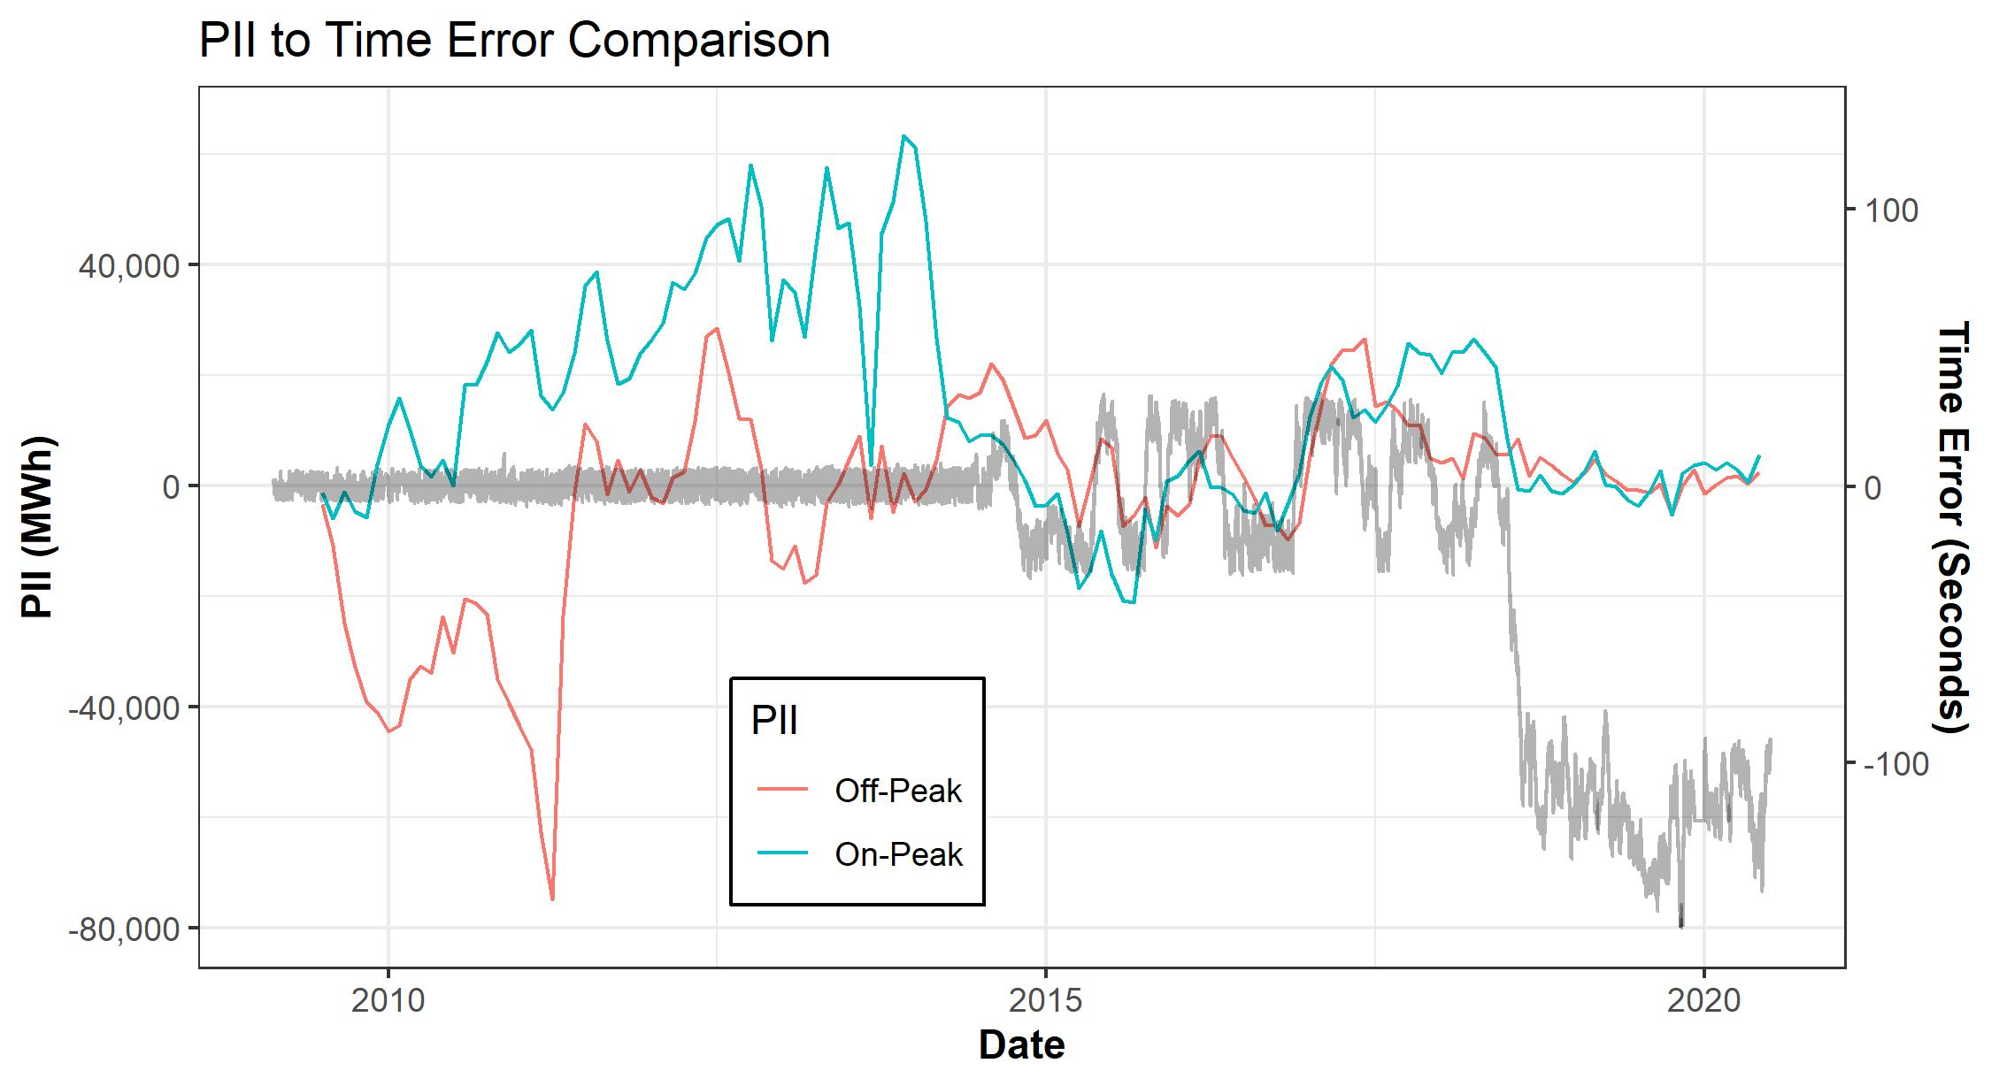
3
4
2
1
- Tracking the accumulated PII over time has helped identify metering errors within BAs.
  - See the large spike on the Off-Peak PII between 2010 and 2015.
- Providing a cap to the amount of PII that a BA can accumulate over time has decreased the major swings.
  - This decrease was due in part to BAL-004-WECC-2 becoming active and causing BAs to bring their accumulated PII into compliance with the accumulation limits in the standard.
- The period in which the Western Interconnection made a change to the MTEC threshold from +/- 5 seconds to 30 seconds.
  - This change allowed ATEC to operate more effectively to help reduce the number of MTECs being called. It should be noted that the PWG made a request to NAESB to increase the threshold event, but was denied because NERC had requested to retire the NAESB standard.
- The period in which BAL-004-0 was retired and the Western Interconnection was able to successfully maintain time error within acceptable bounds. The large movement of time error during this period was due to accumulations of PII balances in the Western Interconnection. Since MTEC ceased and inadvertent balances were reduced overall, the relative time error has been maintained within a relatively tight bound. There have been short periods when schedule errors have occurred, but, once discovered by the deficient entity, the ATEC process returns time error accumulations very quickly.
  - As there is a relationship between time error in the West and PII, a decrease in the accumulated PII would cause a drop in time errors for the West. However, the West is still able to maintain time error during this time with an approximate one and a half minue band range. The reason there is a separation between the two values is that performing MTECs in the West has caused a deviation between the two values. The PWG is currently exploring options on how to reliably bring the two values together.
References:
- The current version of BAL-004-WECC-x:
https://www.nerc.com/pa/Stand/Reliability%20Standards/BAL-004-WECC-3.pdf
- NERC justification for retiring BAL-004-0:
https://www.nerc.com/FilingsOrders/ca/Canadian%20Filings%20and%20Orders%20DL/NEB%20BAL-004%20Filing%20for%20Retirement.pdf
- PWG presentation about time error:
https://www.wecc.org/_layouts/15/WopiFrame.aspx?sourcedoc=/Administrative/Wells%20-%20PII%20TE_April%202020.pdf&action=default&DefaultItemOpen=1
- Latest version of the Western Interconnection performance charts:
https://www.wecc.org/_layouts/15/WopiFrame.aspx?sourcedoc=/Administrative/2020-04%20Western%20Interconnection%20Performance.pdf&action=default&DefaultItemOpen=1

Summary
The Western Interconnection has standards and procedures to address time errors that are under the jurisdiction of the Federal Energy Regulatory Commission (FERC), the North America Reliability Coordinating Council (NERC), and RC West, who is the designated Interconnection Time Monitor for the Western Interconnection. Based on analysis from the WECC PWG, ATEC is working to manage time error in the West but needs to address the accumulated difference caused by performing MTECs in the past. NAESB WEQ-006 should not include references to the Western Interconnection because the standard’s requirements are outdated and contrary to reliable operations as has been discussed, commented, and approved by the industry. In addition, the NAESB standard injects additional complications to the ATEC process that is successfully managing time error in the West.

