Via email and posting

November 27, 2023

**TO:** NAESB Board of Directors, Executive Committee (EC) Members, EC Alternates, NAESB Members, NAESB Advisory Council and Invited Guests

**FROM:** Rae McQuade, NAESB President & Jonathan Booe, NAESB Executive Vice President & COO

**RE:** Announcement of theVirtual NAESB Board of Directors Meeting – December 14, 2023

Dear Board Members, EC Members, EC Alternates, NAESB Members, NAESB Advisory Council and Invited Guests,

As noted during our September meeting and announced last week, NAESB will hold its final Board of Directors meeting of the year on December 14th at 9:00 am Central utilizing the Zoom platform. An agenda and materials for this meeting will be provided to you in the coming days. We are pleased to announce that The Honorable Willie L. Phillips, Chairman of the Federal Energy Regulatory Commission, has graciously agreed to participate and provide some remarks to initiate the meeting, Brett Perlman will give us an update on the Houston HyVelocity Hub project, and Kevin Book, Managing Director, ClearView Energy Partners, LLC, will share his perspectives on the latest developments impacting the energy markets. After their remarks, we will review the progress of the standards development work undertaken this year, the status of the activities by our Board committees, and the proposed 2024 annual plans for each of the quadrants. We will also review and approve the 2024 budget for the organization.

To participate in this meeting, please register through the hyperlink found below. Instructions for participation will be provided to you in a separate emailed confirmation notice after you register. The registration will serve as your RSVP to attend. This meeting is open to all interested parties, and should you have any questions or need additional information, please do not hesitate to contact our office at any time ([naesb@naesb.org](mailto:naesb@naesb.org), (713) 356-0060).

| **Thursday, December 14, 2023** | **RSVP & Registration** |
| --- | --- |
| Board of Directors Meeting  9:00 am to 1:00 pm Central | Please contact the NAESB office |

On behalf of the NAESB staff, we want to thank the Board members for their commitment to our organization, and we look forward to your participation on the 14th.

Best Regards,

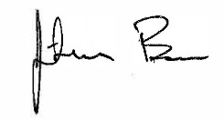



Rae McQuade Jonathan Booe

President, NAESB Executive Vice President & COO, NAESB

**Virtual Board Meeting Instructions**

* Please register through the hyperlink provided in the meeting announcement and agenda. This will serve as your RSVP. Should you have any difficulty registering, please contact the NAESB office.
* After registration, you will receive the meeting link, phone numbers, meeting ID and password. The link you receive is individual – it is specific to your registration and should not be shared. Should you have someone that you would like to invite to the meeting, please contact the NAESB office.
* Meeting participants will be muted on entry to the meeting.
* We ask that the meeting participants remain muted until they are asked to respond to the roll call or have comments or questions. If you have questions or comments, please use the “Raise Your Hand” feature. Once recognized, the meeting participant should unmute themself. When a meeting participant is recognized to speak, the participant should please remember to identify themself and the organization they represent.
* Meeting participants may leave and rejoin the meeting at any time during the session. The session will not be locked.

| **NAESB BOARD OF DIRECTORS MEETING**  **Virtual Meeting – Thursday, December 14, 2023 – 9:00 am to 1:00 pm Central**  **DRAFT AGENDA** | | | | |
| --- | --- | --- | --- | --- |
|  | # | Agenda Item | | |
| 9:00 A | 1. | **Welcome** | | |
|  |  | a) | | Welcome to Board members, guests and convene the December 14, 2023 Board meeting |
|  |  | b) | | Antitrust Guidelines: <http://www.naesb.org/misc/antitrust_guidance.doc> (Guidance) |
|  |  | c) | | Establish quorum: <http://www.naesb.org/pdf4/bod_terms.pdf> (Board Roster) |
|  | 2. | **Consent Agenda** (For Consideration and Vote) | | |
|  |  | a) | | Agenda Adoption: <https://www.naesb.org/pdf4/ec121423a.docx> **(Agenda)** |
|  |  | b) | | Adoption of Draft Minutes: <https://www.naesb.org/pdf4/bd090723dm.docx> (09-07-23 Draft Minutes) |
|  |  | c) | | Adoption of Revised 2023 WGQ Annual Plan: <https://www.naesb.org/pdf4/wgq_ec102623a1.docx> (Redline Approved by the WGQ EC on 10-26-23) |
|  |  | d) | | Adoption of Revised 2023 Retail Annual Plan: <https://www.naesb.org/pdf4/rmq_ec102623a1.docx> (Redline Approved by the RMQ EC on 10-26-23) |
|  |  | e) | | Adoption of Revised 2023 WEQ Annual Plan: <https://www.naesb.org/pdf4/weq_ec102523a2.docx> (Redline Approved by the WEQ EC on 10-25-23) |
|  | 3. | **Introductory Remarks – The Honorable Willie L. Phillips, Chairman, Federal Energy Regulatory Commission** | | |
|  | 4. | **Update on HyVelocity Hub & Hydrogen Market – Brett Perlman, CEO, Center for Houston’s Future** | | |
|  | 5. | **Perspectives on the Evolving Energy Markets – Kevin Book, Managing Partner, Clearview Energy Partners** | | |
|  | 6. | **Membership and Financial Reports** (For Consideration and Vote) | | |
|  |  | a) | | Review of the 2023 Membership and Financial Report: |
|  |  | b) | | Review, Discussion and Adoption of 2024 NAESB Budget |
|  | 7. | **Reports from Board Committees** (For Consideration and Vote) | | |
|  |  | a) | | Managing Committee Update |
|  |  | b) | | Revenue Committee Update |
|  |  | c) | | Strategy Committee Update |
|  |  | d) | | Certification Program Committee Update |
|  | 8. | **Standards Development Efforts** | | |
|  |  | a) | Distributed Energy Resources & Storage | |
|  |  | b) | NAESB Contracts & Distributed Ledger Technologies | |
|  |  | c) | Cybersecurity | |
|  |  | d) | Other Development Efforts: | |
|  | 9. | **Discuss and Approve 2024 Annual Plans** (For Consideration and Vote) | | |
|  |  | a) | | Proposed Wholesale Gas Annual Plan for 2024: <https://www.naesb.org/pdf4/wgq_ec102623a2.docx> |
|  |  | b) | | Proposed Retail Markets Annual Plan for 2024: <https://www.naesb.org/pdf4/rmq_ec102623a3.docx> |
|  |  | c) | | Proposed Wholesale Electric Annual Plan for 2024: <https://www.naesb.org/pdf4/weq_ec102523a4.docx> |
|  | 10. | **Old and New Business** | | |
|  |  | a) | | Regulatory Filings and Related Actions, Liaisons with external groups |
|  |  | b) | | Comments from Board Members, Invited Guests and Attendees |
|  |  | c) | | Board Meeting Schedule 2024: <https://www.naesb.org/pdf4/2024_schedule.pdf> |
|  |  | d) | | NAESB Bulletin, August – October 2023 |
| 1:00 P | 11. | **Adjourn** | | |

**Speaker Biographies**

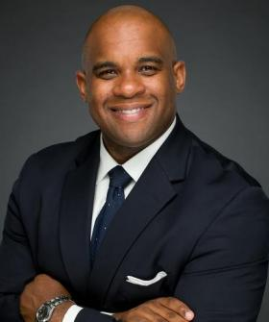

**The Honorable Willie L. Phillips – FERC Chairman**

Willie L. Phillips was named by President Biden to be Acting Chairman of the Federal Energy Regulatory Commission on January 3, 2023 and is serving a Commission term that ends June 30, 2026.

He most recently served as the Chairman of the Public Service Commission of the District of Columbia, named to that role in 2018. He served on the Commission since 2014. He is an experienced regulatory attorney combining nearly 20 years of legal expertise in public and private practice. He has an extensive background in the areas of public utility regulation, bulk power system reliability, and corporate governance.

Prior to being appointed to the DCPSC, Mr. Phillips served as Assistant General Counsel for the North American Electric Reliability Corporation (NERC), in Washington, D.C. Before joining NERC, he also worked for two law firms, where he advised clients on energy regulatory compliance and policy matters.

Mr. Phillips has also served on the boards of several organizations, including the board of directors for the National Association of Regulatory Utility Commissioners (NARUC) and the Organization of PJM States (OPSI). He also has served as president of the Mid-Atlantic Conference of Regulatory Utility Commissioners (MACRUC), and he has held leadership roles on several advisory councils, including the Electric Power Research Institute (EPRI) Advisory Council.

Mr. Phillips has a *Juris Doctor* from Howard University School of Law, and a Bachelor of Science from the University of Montevallo. He lives in Washington, D.C., with his wife and two children.

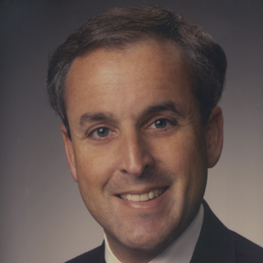

**Brett Perlman – CEO, Center for Houston’s Future**

Brett A. Perlman serves as the CEO of the Center for Houston’s Future, a nonprofit organization working to address matters of highest importance to the long-term future of the greater Houston region. His career has spanned senior positions in business, government and community service organizations. Perlman served for four years as a Commissioner on the Public Utility Commission of Texas, where he was appointed in 1999 by then-Governor George W. Bush. He holds advanced degrees in public policy from Harvard University and in law from the University of Texas, and was a Phi Beta Kappa graduate of Northwestern University.

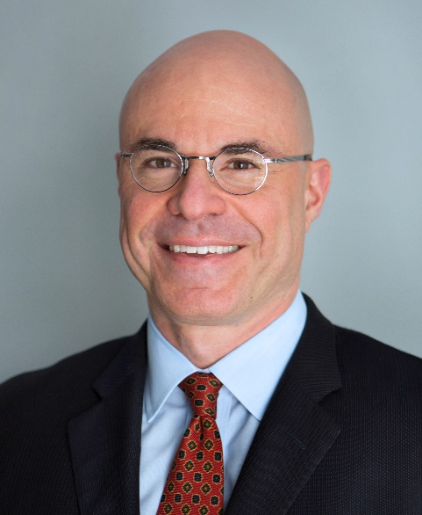**Kevin Book – Managing Director, ClearView Energy Partners, LLC**

Kevin Book heads the research team and covers oil, natural gas, refined products and coal policy.

Mr. Book appears frequently within print and broadcast media, contributes to policy forums convened by government and private organizations and meets with top Washington decision-makers. Mr. Book has also testified before several House and Senate Committees.

Mr. Book is a member of the Council on Foreign Relations. He is also a member of the National Petroleum Council, a self-funded advisory body to the Secretary of Energy, and a nonresident Senior Adviser to the Energy Security and Climate Change Program at the Center for Strategic and International Studies.

Prior to co-founding ClearView, Mr. Book worked as a senior energy analyst for a national investment bank. He holds an M.A. in law and diplomacy from the Fletcher School of Law and Diplomacy and a B.A. in economics from Tufts University.