Via email and posting

November 10, 2022

**TO:** NAESB Board of Directors, Executive Committee (EC) Members, EC Alternates, NAESB Members, NAESB Advisory Council and Invited Guests

**FROM:** Rae McQuade, NAESB President

**RE:** Announcement of theVirtual NAESB Board of Directors Meeting – December 8, 2022

Dear Board Members, EC Members, EC Alternates, NAESB Members, NAESB Advisory Council and Invited Guests,

NAESB will hold its final Board of Directors meeting of the year on December 8th at 9:00 am Central virtually utilizing the Zoom platform, and we are pleased to announce that Bob Gee, Gee Strategies Group, LLC, has graciously agreed to participate in the meeting and provide his perspectives on the NAESB Gas Electric Forum effort and other related efforts taking place in the industry. Mr. Gee’s biography can be found on page three of the posted announcement. Also, during the meeting, we will review the progress of the standards development work undertaken in 2022, the most recent activities of our Board committees, and the proposed 2023 annual plans for each of the quadrants. We will also review and approve the 2023 budget for the organization. The agenda and materials for this meeting supporting the activities described above will be provided to you shortly.

To participate in this meeting, please register through the hyperlink found below. Instructions for participation will be provided to you in a separate emailed confirmation notice after you register. The registration will serve as your RSVP to attend. This meeting is open to any interested party, and should you have any questions or need additional information, please do not hesitate to contact our office at any time ([naesb@naesb.org](mailto:naesb@naesb.org), (713) 356-0060).

| **Thursday, December 8, 2022** | **RSVP & Registration** |
| --- | --- |
| Board of Directors Meeting  9:00 am to 1:00 pm Central | All NAESB meetings are open to any interested party. Please contact the NAESB office. |

On behalf of NAESB, we want to thank the Board members for their commitment to our organization, and we look forward to your participation on the 8th.

Best Regards,





Rae McQuade Jonathan Booe

President, NAESB Executive Vice President & COO, NAESB

**Speaker Biography**

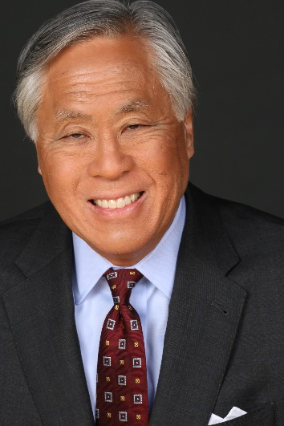**Robert W. Gee - President, Gee Strategies Group, LLC**

Robert W. Gee is President of Gee Strategies Group, LLC, a Washington, D.C. consulting firm providing policy analysis, advocacy, and litigation support for investors, trade associations, utilities, renewable energy companies, independent power companies, and public institutions. A 40-year veteran of the energy industry, he has served as an attorney, senior state and federal public official, and technology executive, combining the fields of law, public affairs, technology, and finance required to address the challenges of global and US domestic energy markets. A recipient of various honors and awards, he has testified before the United States Congress, and provided commentary for Reuters; The Wall Street Journal; the Los Angeles Times; and PBS, BBC, and CNBC television programs. His editorials have appeared in the Los Angeles Times, the Dallas Morning News, and the Houston Chronicle.

He served as Vice President for Development and Partner Relations for the Electricity Innovation Institute (E2I), an affiliate of the Electric Power Research Institute (EPRI), where he advocated development of the “smart grid” to digitize the electric utility power delivery system.

From 1997 to 2000 he served as Assistant Secretary for Policy and International Affairs and as Assistant Secretary for Fossil Energy of the U.S. Department of Energy in Washington, D.C. He chaired the Energy Department’s Central Asia/Caspian energy strategy, and was responsible for the timely completion of the Department's 1998 Comprehensive National Energy Strategy. He also oversaw the operation of the Strategic Petroleum Reserve, and the national research program to develop and demonstrate advanced clean coal, natural gas, and petroleum technologies.

From 1991 until 1997 he served on the Public Utility Commission of Texas and as its Chairman from 1991 through 1995. During his service, he chaired the Committee on Electricity for the National Association of Regulatory Utility Commissioners.

He has served as an Attorney Advisor at the Interstate Commerce Commission and as a Supervisory Trial Attorney at the Federal Energy Regulatory Commission. He held the position of General Attorney at Tenneco Oil Company, and was Of Counsel to the law firm of Akin, Gump, Strauss, Hauer & Feld.

Mr. Gee currently serves on the boards of various institutions, including:

* United States Energy Association (Treasurer)

* North American Energy Standards Board Advisory Council

* Asian Americans in Energy, the Environment, and Commerce (AE2C)(President)

* Committee of 100 (Chair, Washington, DC Region)

His past affiliations included serving as a Trustee for St. Edward's University in Austin, Texas, and as a member of the Dallas Regional Panel of the President's Commission on White House Fellowships.

He is a recipient of various honors and awards, including the distinction of having a hearing room named for him by his colleagues at the Public Utility Commission of Texas.

Mr. Gee received a Bachelor of Arts Degree in government with honors from the University of Texas and a Doctor of Jurisprudence degree from the University of Texas School of Law.