Via email & posting
March 15, 2023
TO: NAESB Members, Gas-Electric Harmonization (GEH) Forum Participants, and Interested Parties
FROM: Michael Desselle, Chairman of the Board of Directors, NAESB
RE: NAESB GEH Forum Effort
Dear NAESB Members, GEH Forum Participants, and Interested Parties,
On behalf of the North American Energy Standards Board (NAESB), I want to thank you for your continued participation in the NAESB GEH Forum activities and for your commitment to answering the call to action requested by the Federal Energy Regulatory Commission (FERC) and North American Electric Reliability Corporation (NERC) last summer. The participants in the GEH Forum have worked diligently to discuss the challenges presented by the increased interdependency of the natural gas and electric industries and to provide their perspectives on what actions should be taken to strengthen the reliability of the bulk electric system. Over the course of our eight meetings and related comment periods and through the participation of diverse parties representing all segments of the supply chain, we have identified numerous coordination, policy and market areas that have the potential for improvement. We have also identified many possible recommendations for action intended to address those areas. In our latest survey issued in February, we asked respondents to indicate whether they support or oppose further consideration of many of the recommendations that have been provided thus far and, for the areas that they do support, also asked for their input on the priority that should be given. We are now at the stage to collaboratively reach a consensus to take the proposals proffered throughout this stakeholder process and craft them into workable solutions, either as standards or proposals for consideration by policymakers , that address the topic areas FERC and NERC identified in Key Recommendation 7 and outlined by FERC and NERC staffs at the onset of effort. Ideally, participants will utilize the information provided by others throughout the process and in the February survey responses to reconsider their own positions and reevaluate the proposals that have been offered to date with a goal of developing realistic recommendations that benefit the industry as a whole.
Many of you have personally contributed significant value to NAESB over the past two decades and know NAESB’s staff to be a small, extremely dedicated team of professionals. Their efforts supporting the GEH Forum have been extraordinary, and I thank them for the work they have performed in collecting all the ideas and comments represented in development of the comprehensive work product to date. Finally, I want to take this opportunity to express my profound gratitude to Sue Tierney, Bob Gee and Pat Wood for acting as Co-chairs of the GEH Forum and volunteering their time and efforts to support NAESB in this endeavor. Their combined experience in the energy industry is unparalleled, and through their leadership, they have all left an indelible mark on U.S. energy policy and the energy markets. We are very grateful for their support and guidance.
With Best Regards,
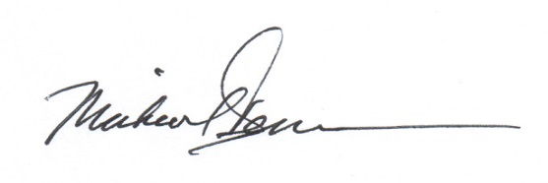
Michael Desselle, Chairman, North American Energy Standards Board
cc: Ms. Rae McQuade, President, North American Energy Standards Board
Ms. Valerie Crockett, Vice Chair, Wholesale Gas Quadrant, North American Energy Standards Board
Mr. Jonathan Booe, Executive Vice President & COO, North American Energy Standards Board

The Presentation can be found through the following hyperlink: https://naesb.org/pdf4/geh083022a1.pdf

