Slide Contents with Additional Notes and Comments including examples:

Sylvia Munson (Sylvia@contentsunderpressurebook.com) is a consultant in the natural gas industry and has worked with producers, distributers, marketers, and pipelines in her career. She specializes in business process improvements, regulatory compliance and IT implementations. Munson has worked with several industry-related organizations and has taught classes on natural gas transportation in three countries. She has participated in NAESB, in numerous roles, since its inception and is currently a board member and co-chair of the WGQ Business Practices subcommittee. Sylvia is the author of Contents Under Pressure – The Complete Handbook of Natural Gas Transportation and maintains a related blog at www.contentsunderpressurebook.com .
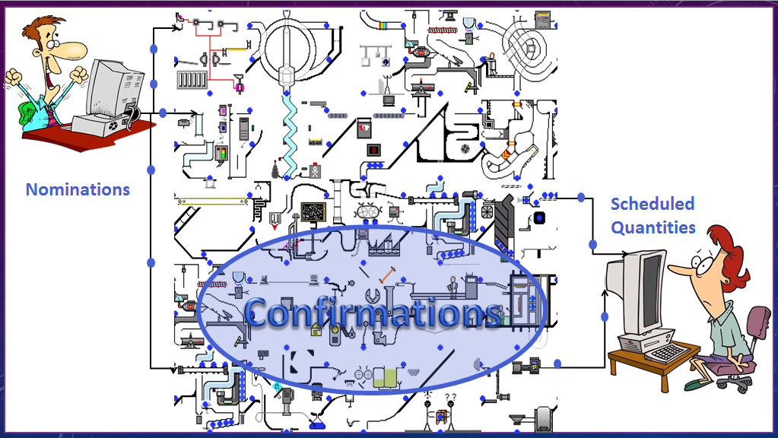
This is how many people view the Scheduling and Confirmations process on a pipeline. It is a mysterious machine where shippers’ nominations are processed, reviewed and an equally mysterious scheduled quantity comes out.
Pipelines have historically kept the scheduling process as a proprietary process and this makes sense. The physical, operational, tariff and market priorities of each pipeline determine many of the steps and processes in the scheduling process and, therefore, make the scheduling process unique for each pipe. The actions that take place during scheduling need to remain proprietary for each pipe.
The confirmations process, however, happens between parties – either pipelines or location operators. Because this is between parties, more definition of what happens and when it happens in the confirmation process will benefit everyone, provide more consistent and timely results, and potentially expedite the scheduling process.
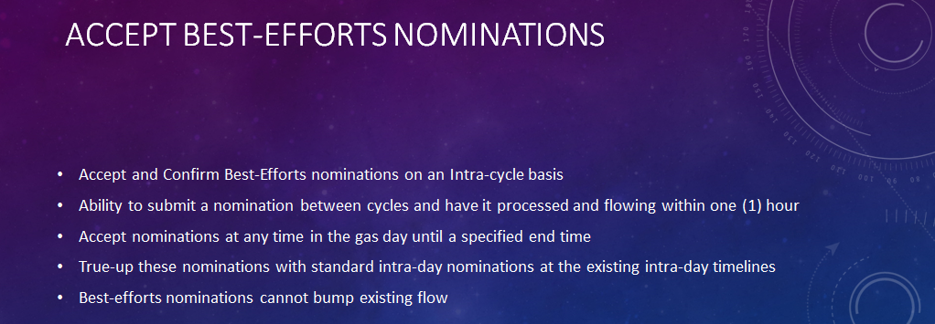
This is not a new concept - Some companies already offer this service
Best Efforts nominations, as they exist in some companies, are used to nominate gas flow after the cycle close and begin gas flow before the next available cycle would have otherwise begun. These nominations can only use available capacity and are not used in situations where the Best Effort nomination would bump another flowing nomination.
How it could work for Intraday 1, as an example:
6 pm Evening Deadline
9 am Gas Flow Begins
10 am Intraday 1 Deadline
2 pm ID 1 Flow Begins

Consider the existing nomination timeline for Intraday 1 nominations. The previous nomination deadline, for Evening Nominations, closed at 6PM on the previous day. Gas began flowing at 9AM on the current day and the first opportunity that shippers have for that gas flow to be altered will begin flow at 2PM.
If Best Efforts nominations are in place, then a change in flow that is found by the shipper can be submitted after the 6PM deadline and be in effect for 5 hours of flow, as early as 9AM, before the flow change that is affected by the Intraday 1 cycle.
The shipper could submit a nomination for the gas flow to change with a flow time beginning as early as 9am. The flow would only be ‘guaranteed’ until the gas is scheduled for the Intraday 1 cycle and therefore the flow is at risk of changing beginning with the 2PM flow time. In this scenario, if the pipeline had adequate capacity to accommodate the Best Efforts nomination, that shipper could receive 5 hours of flow ahead of the 2PM scheduled flow begin time.
This example does incorporate several assumptions:
1 – The Best Efforts process uses available open capacity with no bumping allowed.
2 – The Best Efforts process is an automated process requiring no human interpretation/intervention.
3 – The Best Efforts nomination will only flow until a standard cycle has been run and the nomination is scheduled for flow or cut. At that time, the nomination will be processed with other nominations received for the Intra-day cycle that is being processed.
4 – Confirmation methods are in place, such as automated confirmations or electronic confirmations, to eliminate hands-on confirmations.
5 – The pipeline would not need to run a full scheduling process but would verify capacity at the receipt location, delivery location and any identified intermediate points of constraint.
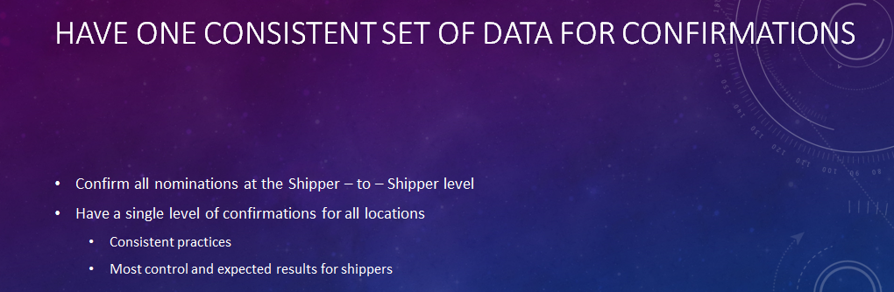
This has been discussed before – via NAESB’s Confirmations and Cross Contract Ranking subcommittee in 1999. At that time, the objective of streamlining confirmations was for a different reason. The effort failed to pass a balanced vote because of various divided interests, though there was common ground obtained in several areas. This is important to know because these changes are not easy changes and will require adjustments and compromise to achieve these changes successfully. In that subcommittee it was found that for the operator confirmation, the shipper to shipper level of confirmation was the most efficient.
The current Confirmations dataset design allows Pipelines to confirm different locations at different levels of detail. The level of detail is set by the pipeline requesting the confirmation. If a small interstate is interconnecting with several large interstates then the smaller interstate may be confirming at multiple levels of detail, which can cause complications for that pipeline, customers and for scheduling.
Interconnect 1
Confirmation Level:
Shipper, Contract, Transaction Type, Package ID

Interconnect 3
Confirmation Level:
Shipper
Interconnect 2
Confirmation Level:
Shipper, Contract

Between a Shipper-to-Shipper-level confirmation at the highest level of detail and the lowest level of confirmation detail there are 14 different pieces of data that may be selected to be used in a confirmation. If we changed this confirmation to contain only two pieces of data, then we eliminate 12 of the options for a confirmation to be un-matched, simplify the process for both the shipper and pipeline and create a consistent business practice. The shipper/shipper level of confirmation leaves the most control of the nomination ranks in the hands of the shippers, rather than the confirming party.
Note: For companies that support multi-tiered confirmations, there may be additional data fields that should be included to support those additional tiers. This is best left up to the committees that develop those datasets to determine. This recommendation only addresses the single tier confirmation between operators at a location.
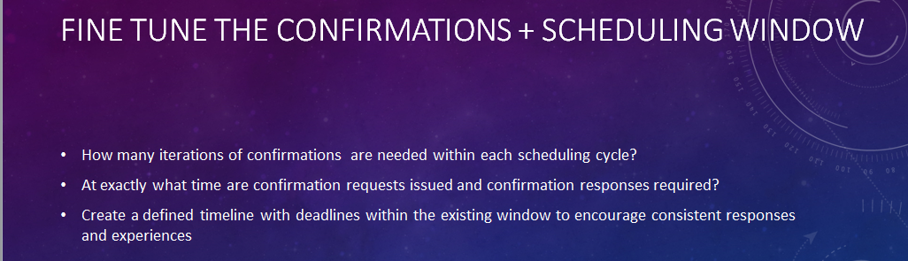
Today, some pipelines conduct one confirmation, with a request and a response, during the confirmations and scheduling window. Other pipelines have 3—4 iterations of a confirmation and the responding party must reply to all of them or risk being cut.
NAESB should define a maximum number of iterations per cycle with a real timeline on when the confirmation will be conducted within the “Scheduling and Confirmations” window of each cycle and the expected results of each iteration. (See NAESB WGQ 1.3.35).
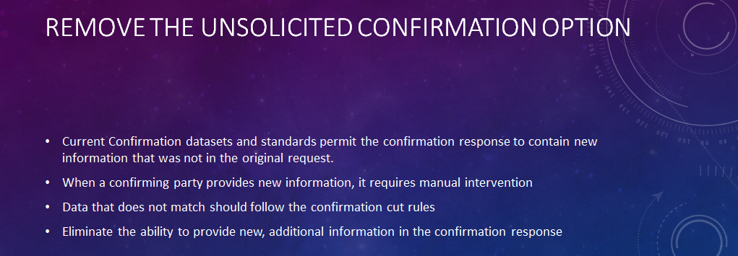
If we create a timeline, as in the previous slide, and a specific set of confirmation steps then there is no longer a need for an unsolicited confirmation because all interested parties will know the process and the cuts that need to be made.
This timeline would need to incorporate the pipeline required scheduling and balancing processes as a component.
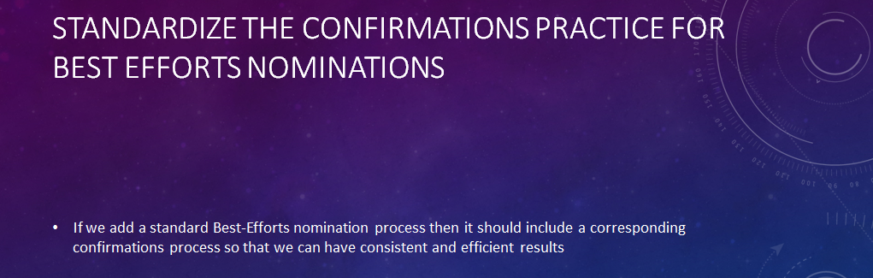
If we add a standard Best-Efforts nomination process then it should include a corresponding confirmations process so that we can have consistent and efficient results.
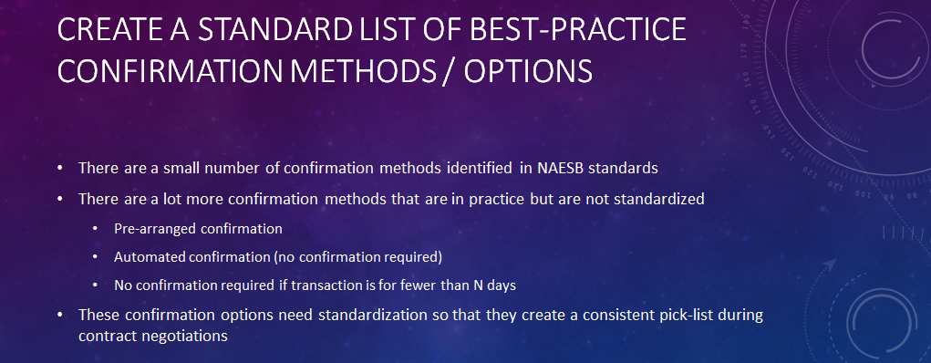
There are a small number of confirmation methods identified in NAESB standards
  - Confirmation by Exception (CBE) – see NAESB WGQ 1.2.11
  - Standard confirmation waiver and unsolicited confirmation waiver – see NAESB WGQ 1.3.20
  - Lesser of Rule – See NAESB WGQ 1.3.22
  - Explicit Confirmation (default) – See NAESB WGQ 1.3.40
There are more confirmation methods that are in practice but are not standardized
  - Pre-arranged confirmation or standing confirmation
  - Automated confirmation (no confirmation required)
  - No confirmation required if transaction is for fewer than N days
  - No confirmation required if transaction is within specified contract terms
  - Etc . . .
These confirmation options need standardization so that they create a pick-list during contract negotiations.
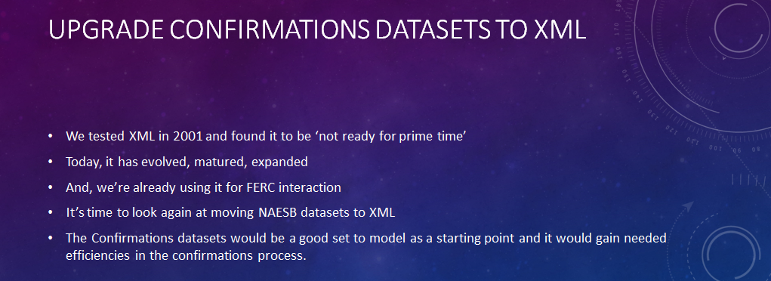
There was an XML Subcommittee in NAESB in 2000 and 2001. At that time, I was CIO of PanCanadian Energy and we participated in a pilot group to develop the XML transaction and test its viability with a couple of other companies. The transactions worked and there were some definite benefits to using them. However, at that point in time, the XML standards were being maintained by more than one competing organization and there was a lot of flux in the standards. We decided, at that time, to let the XML standards mature/evolve and to consider them at a time in NAESB’s future when there were significant changes to the business process or to the data sets that warranted making the move to XML.
Moving to XML ignites fear into a lot of companies because of the huge investment that we’ve all made in EDI. But it’s important for those of us in this room to recognize that the software solutions that are commercially available today, for EDI, are also able to support XML. What I am saying is that you already have XML solutions in place in most existing systems today and the transition to using XML might be simpler than you expect and give you more value than you anticipate.
With the changes that we may have coming out of this process, for Order 809, this is a good time to consider moving the effected datasets to XML.

