​Hotel | 2020 ​Rates | Description
​Radisson Hotel Phoenix Airport North  427 North 44th Street  Phoenix, Arizona 85008  (602) 220-4400/(800) 333-3333  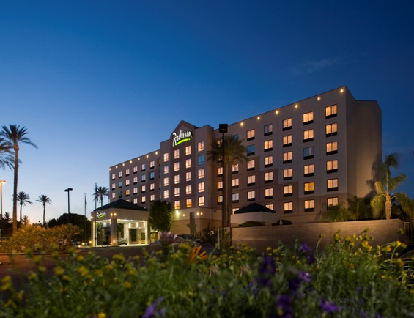 | SRP 2020 rates not finalized | Hotel Features  - Full-service restaurant serves breakfast, lunch, dinner and room service  - Lobby lounge open daily 4pm to 12am  - Complimentary SRP shuttle service scheduling  - Complimentary airport shuttle service and self-parking  - Outdoor swimming pool and patio area  - Business center with complimentary faxing and copying services  - Fitness Center  - Gold Points® Plus program  Room Features  - 27" color television  - Self-controlled heating and air conditioning  - Spacious workstation with desk  - Complimentary Wi-Fi  Minutes from  - SRP’s Tempe Offices  - Phoenix Sky Harbor Airport
Doubletree Suites Phoenix Airport  320 North 44th Street  Phoenix, Arizona 85034  (602) 225-0500​  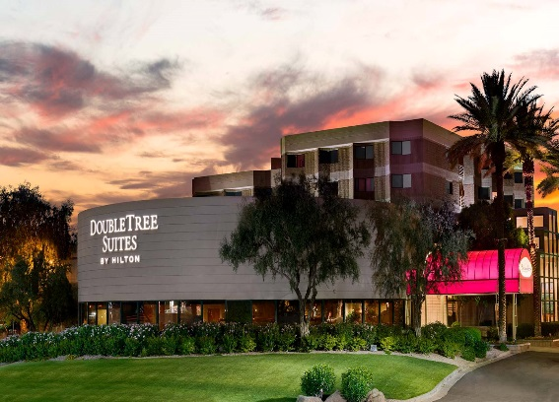 | SRP ​2020 rates not finalized | Hotel Features  - Complimentary hot buffet breakfast daily  - Belvedere American Grill and Lounge - serves breakfast, lunch and dinner with nightly drink specials  - 24/7 complimentary airport shuttle service and self-parking  - Business center  - Precor fully equipped fitness center  - Hilton® HHonors™ Rewards and a warm DoubleTree chocolate chip cookie upon arrival  Room Features  - Spacious two-room suites  - Large desk with adjustable executive office chair  - Two flat screen TV’s  - Microwave, refrigerator and wet bar  - Complimentary Wi-Fi  Minutes from  - SRP’s Tempe Offices  - Phoenix Sky Harbor Airport  - Downtown Phoenix  - Arizona Mills Mall  - Casino Arizona
Hyatt Place Mesa Riverview/Bass Pro  1422 West Bass Pro Drive  Mesa, Arizona 85204  (480) 969-8200  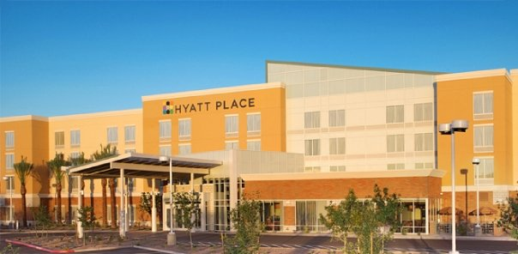 | ​Jan 9-Feb 20: $174  Feb 21-Mar 31: $219  Apr 1-May 22: $132  May 23-Sep 13: $89  Sep 14-Dec 31: $132 | Hotel Features  - Two complimentary drink coupons for SRP travelers  - Complimentary a.m. Kitchen Skillet™, daily 6:30am to 10am  - 24/7 Gallery Menu offers freshly prepared meals  - 24/7 Gallery Market offers perfectly packaged grab ‘n go items, from snacks and sandwiches to pastries and sweets  - Coffee to Cocktails Bar offers specialty beverages made with Starbucks® espresso roast and a variety of premium beers, wines & cocktails  - Complimentary shuttle service within a 5 mile radius, daily 8am to 10:30pm  - StayFit Gym and Nine-hole executive putting green  - Hyatt's Gold Passport Points  Room Features  - Hyatt Grand Bed® and Hyatt Plug Panel™  - Separate workspace  - 42" flat panel swivel HDTV  - Mini-fridge and single-serve coffeemaker  - Complimentary Wi-Fi  Minutes from  - SRP’s Tempe Offices  - Phoenix Sky Harbor Airport  - Tempe Mill Ave District and Tempe Marketplace  - Casino Arizona  - Walking distance to restaurants and shopping
Hyatt Place Tempe/Airport  1413 Rio Salado Parkway  Tempe, Arizona 85281  (480) 804-9544  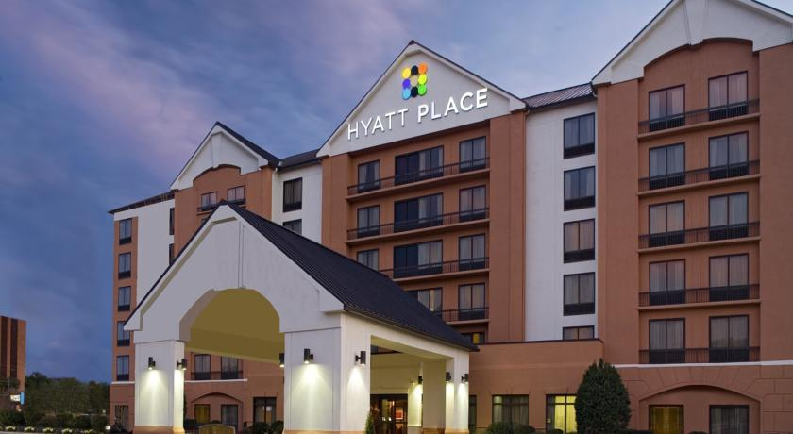  ​ | ​Jan 1-Feb 19: $159  Feb 20-Mar 31: $179  Apr 01-May 22: $122  May 23-Sep 13:$80  Sep 14-Dec 31: $122 | Hotel Features  - Complimentary a.m. Kitchen Skillet™, daily 6:30am to 10am  - 24/7 Gallery Menu offers freshly prepared meals  - 24/7 Gallery Market offers perfectly packaged grab ‘n go items, from snacks and sandwiches to pastries and sweets  - Coffee to Cocktails Bar offers specialty beverages made with Starbucks® espresso roast and a variety of premium beers, wines & cocktails  - Complimentary shuttle service within a 5 mile radius, daily 6am to 11pm  - StayFit Gym  - Hyatt's Gold Passport Points  Room Features  - Hyatt Grand Bed® and Hyatt Plug Panel™  - Separate workspace  - 40" flat panel swivel HDTV  - Mini-fridge and single-serve coffeemaker  - Complimentary Wi-Fi  Minutes from  - SRP’s Tempe Offices  - Phoenix Sky Harbor Airport  - Tempe Mill Ave District and Tempe Marketplace  - Arizona Mills Mall  - Old Town Scottsdale
​Hampton Inn and Suites Phoenix Tempe 1415 North Scottsdale Road  Tempe, Arizona 85281  (480) 941-3441  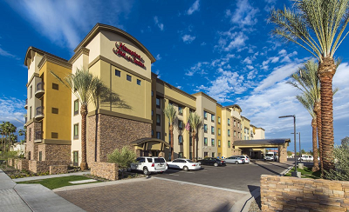 | ​ SRP ​2020 rates not finalized | Hotel Features  - Complimentary hot breakfast daily  - Shuttle service to airport, Mill Avenue, Tempe MarketPlace and SRP  - Fitness center and nearby outdoor activities – hiking, golf  - Dry-cleaning service  - Heated pool and spa  - Hilton® HHonors™ Rewards  Room Features  - Clean and fresh Hampton bed®  - Fantastic views of Camelback Mountain and the surrounding area  - Complimentary Wi-Fi  Minutes from  - SRP’s Tempe Offices  - Phoenix Sky Harbor Airport  - Tempe Mill Ave District and Tempe Marketplace  - Old Town Scottsdale
Holiday Inn Express Hotel and Suites Scottsdale - Old Town  3131 North Scottsdale Road  Scottsdale, Arizona 85251  Phone: (480) 675-7665  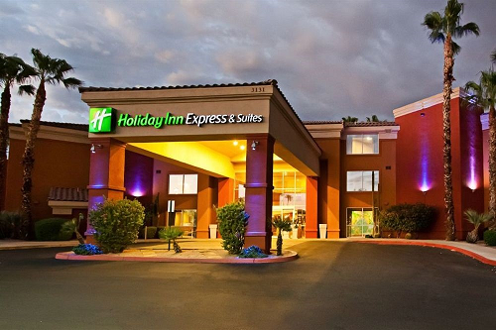 | ​Jan 1-Feb 17: $164  Feb 18-Apr 14: $185  Apr 15-May 15: $164  May 16-Sep 14: $91  Sep 15-Dec 31: $126 | ​Hotel Features  - Complimentary deluxe continental breakfast  - Complimentary Manager’s Reception: Tuesday - Saturday (5:30pm - 7pm)  - Onsite 24-hour business center  - Fully-equipped fitness center  - Outdoor heated pool and spa  - Onsite gift shop  - Complimentary newspaper delivered Monday - Friday  - Complimentary hotel shuttle to destinations within a 3 miles radius of the hotel, daily 7am - 10pm  - Airport shuttle $10 per person to and from Sky Harbor Airport, daily 7am - 10pm  Room Features  - Deluxe Stay Smart Bedding Collection  - Pull-out sofas in every guest suite  - Expanded cable with HBO and pay per view movies  - Microwave and refrigerator  - Complimentary Wi-Fi  Minutes from  - SRP’s Tempe Offices  - Phoenix Sky Harbor Airport  - Tempe Mill Ave District and Tempe Marketplace  - Old Town Scottsdale  - Downtown Phoenix

Residence Inn by Marriot Tempe Downtown/University  510 South Forest Avenue  Tempe, Arizona 85281  (480) 967-2300  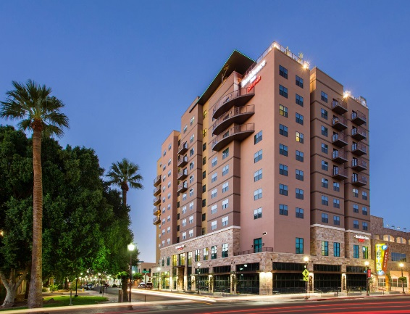 | Jan 1-May 31: $146  Jun 01-Aug 31: $96  Sep 01-Dec 31: $146 | Hotel Features  - Complimentary breakfast  - The Residence Inn Mix™  - 24/7 shuttle service upon request  - Business center  - On-site store  - Outdoor pool and whirlpool  - Fitness center  - On-site laundry  Room Features  - High-speed internet access  - Coffee and coffee brewers  - Microwave and refrigerator  Minutes from  - SRP’s Tempe Offices  - Phoenix Sky Harbor Airport  - Tempe’s Mill Avenue
Hilton Garden Inn Old Town Scottsdale  7324 Indian School Rd  Scottsdale, Arizona 85251  (480) 481-0400 | Jan 1-Feb 14: $209  Feb 15-Mar 21: $269  Mar 22-May 20: $179  May 21-Sep 07: $99  Sep 08-Dec 31: $169 | Hotel Features  - Superb Location, in the heart of Old Town Scottsdale  - 80+ Restaurants, bars, shopping, galleries, and spas within walking distance  - Complimentary wifi  - The BLVD, offering daily cooked-to-order breakfast, a 24-hour sundries shop, and an on-site restaurant and bar for all your cravings  - Onsite Fitness Center  - Business center  - Outdoor pool  - Digital key room access for members of Hilton Honor’s program  Room Features  - Sitting area, refrigerator, microwave, desk, ergonomic chair, HDTV, Wifi  - Relax on the armchair with ottoman and watch premium channels on the HDTV.  - Microwave, refrigerator, and Keurig Coffee Maker  - Complimentary Wi-Fi  Minutes from  - SRP’s Tempe Offices, POB, PAB, and ISB  - Phoenix Sky Harbor Airport

Marriott Chandler  1600 S. Price Rd  Chandler, Arizona 85286  Phone: (480) 732-1600 | ​Jan 1-Apr 09: $219  Apr 10-May 21: $169  May 22-Sep 12: $109  Sep 13-Dec 31: $169 | ​Hotel Features  - Complimentary Parking  - Nearby Shopping and Restaurants @ Chandler Fashion Mall, Downtown Ocotillo, and Downtown Chandler  - Onsite 24-hour state of the Art Fitness Center, featuring a Peloton Bike  - Fresh Bites (Food and Beverage on Demand) available from 6am-10pm  - Café serving Starbucks available from 6am-12am  - Café Meso open from 6am-9pm, serving Modern American Cuisines w/Mediterranean & Southwest influences  - Proof ’19 Bar features local craft beers, a variety of 30 Tequilas, and Chef’s crafted small plates  - Complimentary hotel shuttle to destinations within a 3 miles radius of the hotel, daily 7am - 10pm  - Airport shuttle $10 per person to and from Sky Harbor Airport, daily 7am - 10pm  Room Features  - Deluxe Stay Smart Bedding Collection  - Pull-out sofas in every guest suite  - Expanded cable with HBO and pay per view movies  - Microwave and refrigerator  - Complimentary Wi-Fi  Minutes from  - SRP’s Tempe Offices (TSC)  - Chandler Fashion Mall  - Downtown Chandler

