Battery Task Force work paper
Reliable Energy Analytics LLC
Submitted By: Dick Brooks
https:/reliableenergyanalytics.com
Date: November 3, 2020

Contents
Introduction 1
Framework of Existing Standards 2
NERC DER Planning and Modeling Initiatives 3
Standardization Opportunities for Battery DER/IBR 4
Company Information 7

Introduction
This work paper is being submitted to NAESB in response to a call for work papers issued during the Board Battery Task Force meeting held October 30, 2020. The primary objective is to provide the Battery Task Force with insights into some areas which may benefit from having NAESB developed standards to support battery technologies, as defined by FERC Order 841, within wholesale Electricity markets. The paper begins by introducing a framework of existing standards that are applicable to Battery storage devices used within electricity grids. This is followed by an architectural model showing key concepts and interfaces that are needed to support the participation of battery solutions across the spectrum of Markets, Planning and Operations. The paper concludes with a set of possible areas where NAESB standardization may be highly beneficial.

Framework of Existing Standards
The OpenADR and EPRI organizations have been engaged in studies to understand and plan for the introduction of Inverter Based Devices (IBR) Distributed Energy Resources (DER) onto the electric grid, deployed primarily at the distribution level. FERC Order 841 expands on the possible use of battery technologies, also known as Bulk Electric Storage Systems (BESS), at the transmission level, including their participation in wholesale electricity markets (capacity, energy, ancillary services). The following image shows a hierarchy of standards, pertaining to IBR DER, which includes battery resources, courtesy of the OpenADR organization:
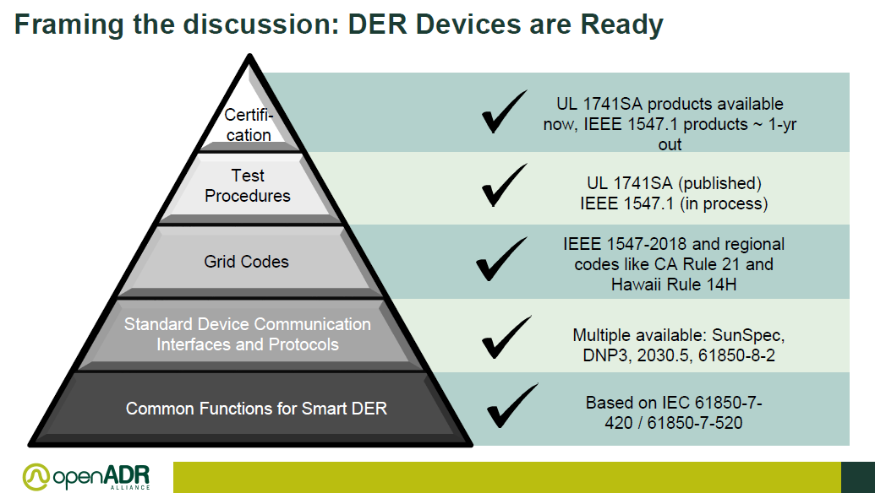
As shown above, there are a number of existing standards in place for IBR DER devices at an operational level that are provided by some highly credible standards organizations, such as IEEE and IEC.
A similar picture is emerging on the planning/modeling front, with work currently underway within NERC

NERC DER Planning and Modeling Initiatives
A Standards Authorization Request (SAR) has been submitted to NERC by the SPIDRWG, a work group focusing on the planning and modeling requirement of DER within the Transmission Grid, titled MOD-032-1 Data for Power System Modeling and Analysis. This standards initiative aims to achieve the following:

As the penetration of distributed energy resources (DER) continues to increase across the North American bulk power system (BPS), it is necessary to account for DER in the planning, operation, and design of the BPS. The NERC System Planning Impacts of Distributed Energy Resources Working Group (SPIDERWG) has identified the need for improved modeling of aggregate DER for planning studies (including both utility-scale and retail-scale DER). MOD-032-1 addresses the gathering of modeling data to build interconnection-wide base cases for the planning horizon but the standard currently has no specific reference to DER data. This SAR proposes to update MOD-032-1 to: (1) include “data requirements and reporting procedures” for DER that are necessary to support the development of accurate interconnection-wide models, (2) replace Load-Serving Entity (LSE) with Distribution Provider (DP) because of the removal of LSEs from the NERC registry criteria, (3) enable the SDT to review any additional gaps in DER data collection with the de-registration of LSE.

This SAR proposes to revise MOD-032-1 to address gaps in data collection for the purposes of modeling and interconnection-wide case creation regarding DER. The goal is to provide clarity and consistency for data collection across Planning Coordinators (PCs) and Transmission Planners (TPs) when coordinating with the DP to gather aggregate load and DER data.

Standardization Opportunities for Battery DER/IBR
Presently, there seems to be relatively little, if any, activity within standards development communities to address standards for DER/IBR participation in wholesale electricity markets to satisfy FERC Order 841 requirements, shown below:
The Federal Energy Regulatory Commission (Commission) is amending its
regulations under the Federal Power Act (FPA) to remove barriers to the participation of electric storage resources in the capacity, energy, and ancillary service markets operated by Regional Transmission Organizations (RTO) and Independent System Operators (ISO) (RTO/ISO markets).

It appears that ISO/RTO organizations are each working on tariff filings to address FERC Order 841 requirements and there are considerable differences across markets. This creates seams issues for battery developers, making it difficult for them to participate in multiple markets, because of the need to understand these differences within each market structure in order to assess investment risk. FERC Order 2222 further expands on Order 841 by enabling technology neutral DER participation by DER Aggregators to sell “grid services” within existing wholesale markets, as show below:
“27 (stating that distributed energy resource aggregations can provide new grid services and enhance competition in wholesale markets as new market participants), 29 (finding that the reforms in this final rule will enhance the competitiveness, and in turn the efficiency, of RTO/ISO markets); see, e.g., infra PP 114 (explaining that the revised definition of distributed energy resource adopted in this final rule is technology-neutral, thereby ensuring that any resource that is technically capable of providing wholesale services through aggregation is eligible to do so, which enhances competition in the RTO/ISO markets) “
FERC Order 2222 uses the phrase “grid services” to describe the potential offerings that a DER Aggregator may submit for sale within wholesale electricity markets. The exact definition of what exactly constitutes a “grid service” is not widely agreed upon, leaving open the need for standardization work in defining the “grid services” that will be available through wholesale markets nationally and how each service is characterized, consistently – within each wholesale market. There are some efforts presently underway in Hawaii to address the need for standard/common definitions and characterizations of grid services for DER, but this work is just beginning.
FERC Order 2222 specifically identifies the need for ISO/RTO organizations to exchange data with DER Aggregators for participation in wholesale markets, this is referred to in the diagram below as the “Commercial Interface”:
add § 35.28(g)(12)(ii)(d) to the Commission’s regulations to require each RTO/ISO to establish market rules that address information requirements and data requirements for distributed energy resource aggregations. Specifically, we require each RTO/ISO to revise its tariff to (1) include any requirements for distributed energy resource aggregators that establish the information and data that a distributed energy resource aggregator must provide about the physical and operational characteristics of its aggregation;

The diagram below shows areas open to standardization, in order to support Battery DER participation in wholesale markets:
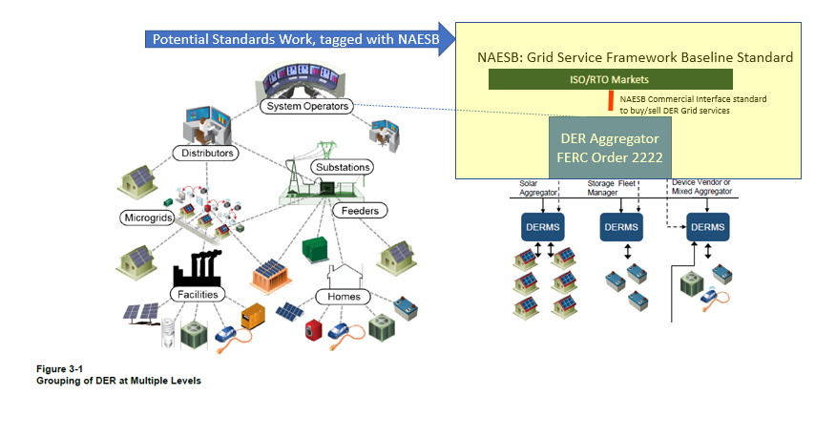
Enabling Battery DER to offer standardized Grid Services into wholesale markets (capacity, energy and ancillary services) will ensure that these battery resources are receiving appropriate compensation for the valuable services they provide to a grid operator, and a grid operator will have access to reliable, fast performing resources to address challenging operating conditions, for example:
- Fast ramping, both up and down
- Super-peak response
- Frequency response
- Ultra-fast start capability
- Dispatchability for intermittent resources, such as wind and solar

Other seams issues continue to inhibit battery developers from participating in other service areas nationally; one difficult issue in particular is the varying interconnection requirements that exist across State jurisdictions. A standard set of interconnection requirements for Battery DER that has national support with regulators, e.g. NARUC, would provide additional support for broad industry adoption of Battery Resources to provide valuable grid services nationwide. This may present an opportunity for close collaboration between NERC and NAESB to ensure harmony across planning and market interfaces/standards.

Company Information
Reliable Energy Analytics LLC
Dick Brooks
https:/reliableenergyanalytics.com

18 CFR Part 35 [Docket Nos. RM16-23-000; AD16-20-000; Order No. 841] Electric Storage Participation in Markets Operated by Regional Transmission Organizations and Independent System Operators (Issued February 15, 2018)
18 CFR Part 35 [Docket No. RM18-9-000; Order No. 2222] Participation of Distributed Energy Resource Aggregations in Markets Operated by Regional Transmission Organizations and Independent System Operators (September 17, 2020)

