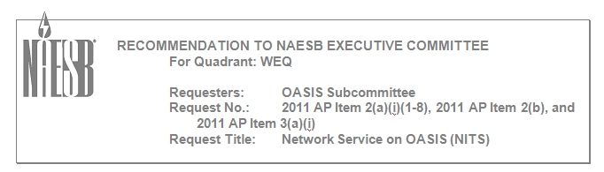

Comments from Tennessee Valley Authority
on the Proposed NITS Recommendation
July 29, 2011

General Comments

- General speaking there don’t seem to be any roadblocks in the standard; however the standards require a lot of data and software development and some items are unclear. 8/3/11 NAESB does not normally do cost/benefit analysis.
- The standards are not clear that new customers go through the Application for NITS and existing customers go through the Modification to NITS process. It is further not clear exactly if, what, or how to enter the information for grandfathered NITS arrangements. For instance can all grandfathered resources be entered as one or does each resource have to be entered separately? Similarly will all non-grandfathered, but post 888 arrangements need to be entered separately? (Note, the minimum information required for conversion is listed in WEQ 002-5.10.1, but the specifics are not clear.) 8/3/11 this standard is for NITS service under section 3 of the OATT. The information to be enter in for these existing NITS customers (post 888) may be found in WEQ-002-5.10.1. All pre 888 arrangements requirements are found in WEQ-001-19.
- The standards are not clear if each customer can have one load request to cover all load with multiple resource requests? Or does each resource have to have matching load? 8/3/11 No More specifically, can the load be the load of the system or is it a delivery point load? System load would be easier to update with new load forecasts.8/3/11 this standard left the implementation of reporting load on OASIS up to the Transmission Provider such that the granularity of forecasting and scheduling can be accommodated.
- The attestation field and Auxiliary Transmission fields need the capability to be modified. For instance some TPs may have an automatic check when transmission service is scheduled to verify the auxiliary transmission…if the Transmission has been altered for any reason on the third-party systems, it will cause the tag to fail. This can cause problems and will require the original NITS request on your system to be superseded with a new request to correct the third-party transmission information. 8/3/11 the intent was not to verify auxiliary transmission at the time of tag. The intent was the delivery of the service is firm at the time of designation not OASIS numbering being identical on third parties at the time of tagging. Should we put something in tagging to accomplish this? At this time this can be managed by concomitant requests.
- The differences in Resource, Generation, and DNR are not apparent. It seems like the same data will be entered in multiple fields which could lead to more confusion than value add. Why would a customer request NITS for a resource that isn’t qualified to be a DNR? 8/3/11 this was request by the subcommittee to be developed in this fashion to accommodate resources being specified for future uses.
- The idea of NSRs is also confusing…why would NSRs be different than the approved NITS for the DNR? How could a resource have more NSRs than the resource itself? If the DNR was more than the NSR, would the DNR have to be restudied in order to get the NSRs to actual schedule transmission? 8/3/11 will be discussing this concept in the DUKE informal comments. Refer to the answer in that concept talk.

Response to DUKE informal comments 8/3/11 Keep the NSR as optional. Need to address the optionality in weq-002. Need to address weq-001 as a request type do we need to keep this or new concept (such as dnr, dnl). Need address e-tag specifications to be worked along with nits. Need to put in examples for nsr concept. Need to manage nits scheduling rights from dnr to dnr.

