# ISO-NE, NYISO, PJM, MISO, SPP and ERCOT (ISO Group) Comments on the gas day alternatives being considered by NAESB[1]

The ISO Group supports the 4 a.m. CCT start to the gas operating day for the reasons set forth in the FERC NOPR and summarized below. Reliable electric energy delivery on demand is critical to businesses and for the public good. The objective behind moving the start of the Gas Day earlier and moving the timely nomination to 1 p.m. or later is to enable gas-fired resources needed for the peak morning period to timely nominate and schedule supply to support their ability to generate electricity at the start of the morning electrical ramp. Meeting that objective should substantially mitigate the concern that some gas-fired generators may not be able to run during a substantial part of the morning ramp period because they have burned through their nominated gas before the start of the next Gas Day.

The current 9 am Gas Day start time presents operational challenges because it occurs when gas-fired generation is critically needed to ensure that supply is available to match demand during the morning electric load ramp. The morning ramp is driven by the public consumption of energy and is outside the control of electric grid operators. As gas-fired generators approach the end of the Gas Day during the morning electric load ramp, they could exhaust their supply of natural gas.When this occurs the electric grid operators must search for alternative available generating units while electric load is ramping up and approaching its morning peak. This probability and frequency of this circumstance occurring will likely rise as gas-fired generation continues to increase and available short notice replacement ramping from non gas-fired resources is reduced thereby making it increasingly difficult to maintain reliable operations. As the Commission stated in the NOPR, moving the start of the gas day earlier should address instances where gas-fired generators find they are running out of scheduled natural gas capacity during the morning ramp period and have to wait until 9:00 am CCT start of the Gas Day.[2] In addition, the current Gas Day start time straddles a time of peak gas demand for other pipeline shippers, such as LDCs, which further inhibits the ability to procure gas during the morning ramp.[3]

Moving the Gas Day to coincide with the start of the morning load pick up allows that necessary gas flow to be largely planned for in the gas operating day through the timely nomination process. On the other hand, the continuation of a 9 am Gas Day means that fuel and transportation to meet the morning ramp must be managed over two Gas Days. Planning for and including all of the morning ramping hours in the initial gas day operating plan is inherently more reliable to serve load requirements and may reduce the need to change valve positions to provide unplanned for supply in the early morning hours.

The Commission proposal to move the start of the Gas Day to 4:00 a.m. CCT and the Timely nomination to 1 p.m. accommodates the timing of the morning electric ramp periods across all four time zones and provide generators in all regions the ability to approach the morning electric peak, as well as most of the morning ramp period, with timely daily gas nominations. The alternative proposals (6 a.m., 7 a.m., and 9 a.m. CCT) do not meet the desired objective.

As Figures 1 and 2 from the FERC NOPR below show, a 4:00 a.m. CCT Gas Day start time would occur near the beginning of the morning electric ramp in the East, and before the morning electric ramp in other regions of the country. Although the Figure 1 graph shows that beginning of the Electric ramp in the East occurs somewhat earlier than 4 a.m. (as early as 2 a.m. in some regions) the proposed 4 a.m. start captures most of the morning ramp period in the East and as shown on Figure 2 all of the morning ramp in the West. Starting the gas day at 4 a.m. also accommodates the entirety of the electric operating day peak period (morning and evening peaks) for all regions of the country.

By contrast, the alternative later gas day start times still under consideration at NAESB do not produce these outcomes. A start time of 6 a.m. or 7 a.m. would fall squarely in the heart of the period when electric load is ramping up and approaching its morning peak in the Eastern and central regions of the country. Obtaining the necessary changes in flow from producers and scheduling the necessary early morning period supply through the intraday scheduling process at the end of the prior gas day for the missing hours that were left out of the timely nomination is inherently much more difficult and less reliable relative to planning for those requirements in advance through the timely nomination cycle. Such later start times and reliance on the intraday cycle to address that portion of the electric day-ahead energy schedule would perpetuate the concern associated with the current operating day in that some gas-fired generators may be unable to run during a substantial part of the morning ramp period because they have burned through their nominated gas before the start of the next Gas Day. Similarly preserving the even later 9 a.m. start of the gas operating day fails to address this concern, even in conjunction with the later 1 p.m. Timely Nomination deadline.

**Figure 1 - Recent winter load – Eastern and Central Regions (non-holiday weekdays, Dec.-Feb.) 56**

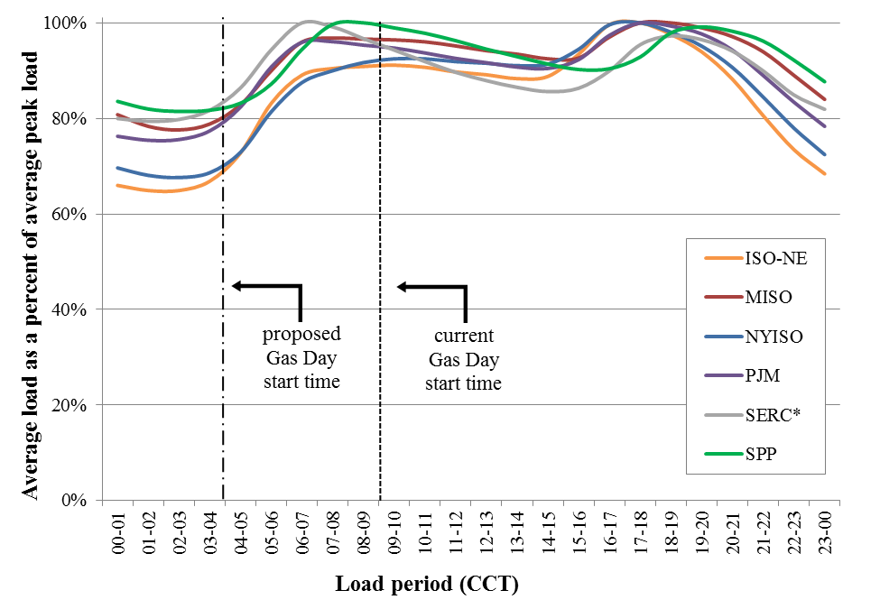

**Figure 2 - Recent winter load – Mountain and Pacific Regions (non-holiday weekdays, Dec.-Feb.)**



Finally, moving the Gas Day to 4 am or earlier may provide an opportunity to develop changes to the timing of the electric day to better coincide with the Gas Day. Because the electric morning load ramp begins at or before 4 am for several electric grid operators, moving the electric day after 4 am is not operationally feasible. However, an electric day that captures the morning load ramp and coincides with the Gas Day is an objective that could be considered in the regional RTO stakeholder processes.

1. CAISO is not joining these comments because it can support all the proposed gas day start times. However, consistent with that position, CAISO is not opposed to the 4 AM gas day. Notwithstanding that the IESO is not FERC jurisdictional, the IESO is not joining these comments because it can support all the proposed gas day start times. AESO is not FERC jurisdictional and is not joining these comments.
2. FERC NOPR at P 39.
3. FERC NOPR at P 36.