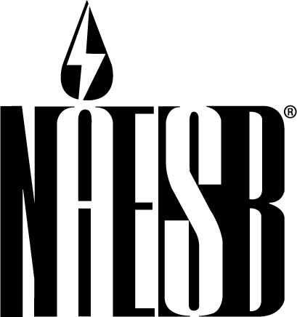

NORTH AMERICAN ENERGY STANDARDS BOARD
1301 Fannin, Suite 2350
Houston, Texas 77002
713-356-0060/Fax 713-356-0067

Contact: Rae McQuade For Immediate Release
(713) 356-0060 Tuesday, June 30, 2009

NAESB Releases Updated, Expanded Compendium of Model
Business Practices Developed by Retail Gas and Electric Quadrants

HOUSTON—The North American Energy Standards Board (NAESB) has published an updated and expanded compendium of model business practices (MBPs) developed by its two retail quadrants.
Retail Gas Quadrant, Retail Electric Quadrant, Business Practice Standards, Version 1.1 includes 501 MBPs on market participant interactions; creditworthiness; billing and payments; distribution company–supplier disputes; quadrant-specific electronic delivery mechanisms; contracts; Internet electronic transport; customer information; customer billing and payment notification via uniform electronic transactions; customer enrollment, drop and account information change; and customer enrollment, drop and account information change using a registration agent. There is also a glossary of 105 business terms, 54 principles and 25 electronic transactions defined, including data layouts.
MBPs on demand response and measurement verification will be published in a supplement later this year.
The initial (1.0) version of retail MBPs was published in September 2005.
NAESB President Rae McQuade said, “I’m very proud of the work done by the retail electric and retail gas quadrants in preparing this greatly expanded version of retail MBPs for publication. This project required a tremendous amount of work and coordination, and the volunteers who labored long hours to bring it to a successful conclusion deserve the thanks of the entire industry.”
McQuade noted that the MBPs, which are largely commodity neutral, mainly address customer choice programs. She noted that some standards are specific to Texas and that state’s registration agent model. There are also standards dealing with billing and payment practices for national accounts with multiple locations as well as large electric aggregators, McQuade said.
J. Cade Burks, executive vice president of E:SO (formerly EC Power) and a member of NAESB’s Board of Directors for the service providers segment of the Retail Electric Quadrant, commented, “The NAESB office coordinated a massive effort on the part of industry participants to compile these standards, which benefit the entire energy market because they keep transaction costs down, in turn reducing costs to end use consumers. In addition, every transaction that moves from paper to electronic format further cuts costs and benefits the environment.”
Ruth Kiselewich, director of demand side management programs at Baltimore Gas & Electric Co. and a NAESB board member representing the distributor segment of the Retail Electric Quadrant, said release of version 1.1 of the retail MBPs “demonstrates once again the value of NAESB and its model of collaboration among all commodities, industry segments and market participants. This is another milestone for our organization.”
NAESB, formed in January 2002, is an independent and voluntary North American organization that develops and promotes the use of business practice and electronic communications standards for the wholesale and retail natural gas and electricity industries. NAESB is the successor to and is modeled after the Gas Industry Standards Board, which was established in 1994 and now constitutes the Wholesale Gas Quadrant of NAESB. NAESB’s members include over 300 companies and organizations that participate actively in the retail and wholesale natural gas and electricity markets.

# # #

