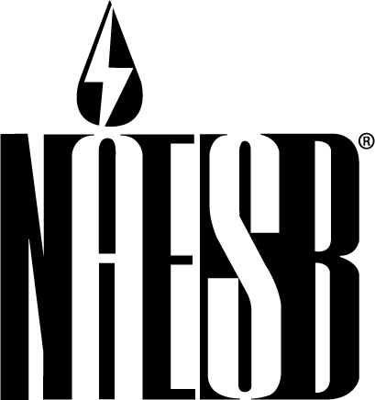

NORTH AMERICAN ENERGY STANDARDS BOARD
1301 Fannin, Suite 2350
Houston, Texas 77002
713-356-0060/Fax 713-356-0067

Contact: Rae McQuade For Immediate Release
(713) 356-0060 Wednesday, April 22, 2009

NAESB Files Wholesale Electricity Demand Response Standards at FERC;
Comparable Effort Now Under Way on Retail Side

HOUSTON—The North American Energy Standards Board (NAESB) has filed a series of electricity demand response standards with the Federal Energy Regulatory Commission (FERC).
The standards address the measurement and verification characteristics of demand response products and services to be used in the wholesale electricity market. They are intended to provide a common framework for transparency, accountability and consistency.
The 31 business practice standards and 40 definitions address four product and service categories—energy service, capacity service, reserve service and regulation service—and establish criteria for the use of equipment, technology and procedures to quantify the demand reduction value delivered.
NAESB Chairman and CEO Michael Desselle, vice president, process integrity, Southwest Power Pool, said, “This is a good first step in the effort to develop measurement and verification standards based on the 45 demand response products and service operational in the wholesale electric market today.
“We expect that these standards will prove beneficial to designers of new demand response products and services as well as facilitate the advancement of Smart Grid enhancements,” Desselle continued. “As an added benefit, a greater understanding of the current market for demand response products was gained by all participants as the ISOs and RTOs reviewed and compared notes on their demand response products and services.
NAESB President Rae McQuade said, “The effort undertaken by the Demand Side Management–Energy Efficiency Subcommittee of the Wholesale Electric Quadrant (WEQ) is already reaping benefits for the wholesale electric market.
“Now that we have the foundational standards, we can begin to build in more granularity,” McQuade said. “With our subcommittee structured so that each participant has an equal voice in the outcome, we should deliver work products representative of the market.”
McQuade noted that a comparable effort is under way by the Retail Electric Quadrant (REQ) using the foundation set by the WEQ standards, and it is expected that NAESB will have retail demand response standards in place by the second quarter of 2009.
The wholesale standards submitted to FERC has been ratified by the NAESB membership and will be included in the next publication of WEQ standards, currently slated for the first quarter of 2010. The filing was made in FERC Docket RM05-5-000 and can be downloaded from both the FERC and NAESB web sites.
NAESB, formed in January 2002, is an independent and voluntary North American organization that develops and promotes the use of business practice and electronic communications standards for the wholesale and retail natural gas and electricity industries. NAESB is the successor to and is modeled after the Gas Industry Standards Board, which was established in 1994 and now constitutes the Wholesale Gas Quadrant of NAESB. NAESB’s members include over 300 companies and organizations that participate actively in the retail and wholesale natural gas and electricity markets.

# # #

