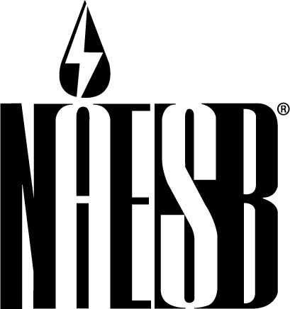

NORTH AMERICAN ENERGY STANDARDS BOARD
801 Travis Street, Suite 1675
Houston, Texas 77002
713-356-0060/Fax 713-356-0067

Contact: Rae McQuade For Immediate Release
(713) 356-0060 Wednesday, April 21, 2010

NAESB Appreciates FERC Recognition of NAESB Standards
On Wholesale Electricity Demand Response Products and Services

HOUSTON—The North American Energy Standards Board (NAESB) appreciates the recognition given in the order issued by the Federal Energy Regulatory Commission (FERC) adopting a series of electricity demand response standards developed by NAESB.
In Order 676-F, FERC incorporated by reference standards addressing the measurement and verification characteristics of demand response products and services to be used in the wholesale electricity market. They are intended to provide a common framework for transparency, accountability and consistency.
NAESB filed the standards with the commission in 2009.
The 31 business practice standards and 40 definitions address four product and service categories—energy service, capacity service, reserve service and regulation service—and establish criteria for the use of equipment, technology and procedures to quantify the demand reduction value delivered.
Both the wholesale and the retail electric markets interests within NAESB collaborated on the development of these standards as there is interdependency between both markets as demand response products and services are made available. The development work was also coordinated with the North American Electric Reliability Corporation (NERC), and in particular the development of the definitions – as the definitions play a role in the NERC demand response data collection efforts, known as Demand Response Availability Data System.
“We greatly appreciate the confidence that FERC continues to show in NAESB and its standards-setting process,” said Michael Desselle, Wholesale Electric Quadrant vice president of the NAESB Board of Directors. “Through the NAESB process, stakeholders from the retail and wholesale electric markets were able to analyze existing demand response products and services and identify standards that provide a more robust market for demand response through standardized access to information, increased participation and reduced transaction costs.”
Desselle, vice president and chief administrative officer of the Southwest Power Pool, added, “Coordination and collaboration with other groups as the standards are developed was crucial. The NAESB process brought together all aspects of the market not only to provide input but also to prepare and vote on the work products.”
Rae McQuade, president of NAESB noted, “Several groups lent their considerable expertise to the development of these standards. The ISO-RTO Council (IRC) prepared a matrix of demand response products and services that served as a resource for standards development.
“We very much appreciated the efforts put forth by the IRC members, aggregators, marketers, utilities, end users, demand response providers and energy associations as these standards were formed. Without them, we would not have the work products we have today,” McQuade said.
She said NAESB is now developing standards that build on those adopted by FERC. In its order, FERC noted the benefits of such continued development and asked NAESB to complete its work within one year of the effective date of the order.
“We look forward to working with the groups that supported the development of our first set of demand response standards and welcome any others who may have an interest in demand response standards,” McQuade said.
NAESB Chairman Ralph Cleveland, executive vice president of engineering and operations for AGL Resources Inc., thanked everyone who participated in the first round of standards development and encouraged them and others to help with the next stage.
“Our process is open to any interested party, and the intent of our work products is to provide support for a strong market—in this case, for demand response. This is an important effort and I urge you to consider participation,” Cleveland said.
NAESB, formed in January 2002, is an independent and voluntary North American organization that develops and promotes the use of business practice and electronic communications standards for the wholesale and retail natural gas and electricity industries. NAESB is the successor to and is modeled after the Gas Industry Standards Board, which was established in 1994 and now constitutes the Wholesale Gas Quadrant of NAESB. NAESB’s members include over 300 companies and organizations that participate actively in the retail and wholesale natural gas and electricity markets.

# # #
For additional information:
FERC Order No. 676-F, Docket No. RM05-5-017, is available at http://elibrary.ferc.gov/idmws/common/opennat.asp?fileID=12321975
The NAESB report to the FERC is available at http://www.naesb.org/pdf4/ferc041709_dsm_filing.pdf
The ISO-RTO Matrix is available at: http://www.isorto.org/atf/cf/%7B5B4E85C6-7EAC-40A0-8DC3-003829518EBD%7D/IRC%20DR%20M&V%20Standards%20Implementation%20Comparison%20(2009-04-28).xls

